**© 2018 Sukanya Sharma**

IMPACT OF SHORT TERM RENTALS ON THE RENTAL AFFORDABILITY IN SAN FRANCISCO – THE CASE OF AIRBNB

BY

SUKANYA SHARMA

THESIS

Submitted in partial fulfillment of the requirements

for the degree of Master of Urban Planning in Urban Planning

in the Graduate College of the

University of Illinois at Urbana-Champaign, 2018

Urbana, Illinois

Masters Committee:

Associate Professor Bumsoo Lee

Assistant Professor Andrew Greenlee

ABSTRACT

The short-term rental housing options supported by the sharing economy have now been established as disruptions in the housing and tourism sectors. With the advent and proliferation of Airbnb rentals all over the world, questions have been raised about their impacts (Meni, 2017). While one side discusses the democratization of tourism industry and how Airbnbs makes it easier for tourists to travel and experience places, the other side brings forth the skirting of hotel taxes and negative neighborhood externalities that inevitably result from these rentals. Airbnb has attracted controversy in cities all over the world, with high-profile lawsuits centered around criticism for evasion of taxes and for avoiding regulatory oversight that is otherwise enforced on hotels and providers of similar services. The presented research is an attempt to gauge the impact of Airbnb on rental affordability by using spatial econometric analyses. The study areas for the aforementioned research is the San Francisco Metropolitan Statistical Area (SF MSA).

The hypothesis is that an increase in the Airbnb listings (i.e. the short-term housing stock) in the study area is correlated negatively with rental affordability, causing it to decrease. Key research questions are *does Airbnb impact the rental affordability in an area? If yes, then, to what extent?* To answer these questions, both cross-sectional and longitudinal analyses are undertaken. Aiming to contribute to the body of literature, revolving around the debate through quantitative analyses and regulatory policy discussion, this study finds positive and statistically significant correlation between both Airbnb variables (percent Airbnb listings as a proportion of rental housing units and weighted Airbnb listings based on listing types) and variables representing rental affordability like percent rent-burdened[1] and overburdened[2] households, median rents and median house prices). Various models were considered for both cross-sectional and longitudinal analyses using different combinations of the aforementioned variables. The spatial econometric analysis answers one of our key questions in the affirmative – the presence of Airbnb rentals *does* impact the rental affordability in an area.

Having established a relationship, our second objective was to gauge this impact’s extent. Simulations were run to understand the results of the spatial econometrics models to help visualize this impact. In the case of cross sectional analysis for San Francisco MSA, these simulations showed that for a typical census tract (one with median percentage of Airbnb listings, as a fraction of the rental housing market) a 1% increase in Airbnb listings corresponded to a 0.06% rise in the rent overburdened household category. Hence, in the case of a census tract with 10,000 households, a 10% increase in percent Airbnb listings will correspond to 60 more households being added to the rent overburdened category. This effect is more pronounced for tracts with a lower number of Airbnb listings (10th or 25th percentiles). Additionally, tracts with no or a low percentage of Airbnb listings will have more households pushed to a rent-burdened category, with a similar rise in Airbnb listings.

In the case of longitudinal analysis of panel data for San Francisco City for a period of four years (2013 – 2016), the simulations show that census tracts with a smaller presence of Airbnb listings (those below the 50th percentile) were more sensitive to an increase in Airbnb listings i.e. they saw a higher increase in the median house price per tract as compared to census tracts in the higher percentiles. This trend was consistent across all four years affirming the extent of the impact of Airbnb listings on the rental affordability in an area.

ACKNOWLEDGEMENTS

First and foremost, I would like to express my sincere gratitude to my advisor Prof. Bumsoo Lee for his continuous support, patience, motivation, enthusiasm, and immense knowledge. His guidance helped me throughout the research. I could not have imagined having a better advisor and mentor.

Besides my advisor, I would like to thank Prof. Andrew Greenlee for insightful comments and encouragement. His positivity and patience were crucial for the success of this research. I also want to thank the Department of Urban and Regional Planning at UIUC for all the support and resources.

I would like to take this opportunity to express immense gratitude towards Vaibhav Karve, for his constant support and stimulating discussions. Without his support this study would not have attained its current form. I also want to thank my friends and classmates Gavin, Ziqi, Anusha and Tooma for all the support. I highly appreciate their constant support all through the last one year, even when it seemed extremely hard to continue.

Last but not the least, I would like to thank my family: my parents Anupama and Sanjay Sharma, and my beloved brother Shekhar, without whose motivation and support, I wouldn’t have been able to complete this research.

*Sukanya Sharma*

*July 2018*

*For my family*

Table of Contents

List of Tables vii

List of Figures vii

CHAPTER 1. INTRODUCTION 1

1.1 Background 1

1.2 Hypothesis 2

1.3 Objectives and Methodology 2

CHAPTER 2. LITERATURE REVIEW 4

2.1 The Sharing Economy 4

2.2 Airbnb disruption 6

2.3 Housing Affordability 10

2.4 Spatial Econometrics 13

CHAPTER 3. DATA AND METHODS 15

3.1 Cross-sectional Analysis 15

3.2 Dataset Generation 16

3.3 Methods 21

3.4 Longitudinal Analysis 23

3.5 Dataset generation 24

3.6 Methods 27

3.7 Limitations 28

CHAPTER 4. RESULTS 29

CHAPTER 5. DISCUSSION AND CONCLUSION 41

References 44

Appendix A – ArcGIS map outputs 47

Appendix B - Graphs depicting distribution of Airbnb listings and DATA REPOSITIRY 48

Appendix C – Simulation outputs 49

# 

# List of Tables

Table 1 Learnings from literature review of selected papers and reports 7

Table 2 Brief description of variables used in cross-sectional analysis 19

Table 3 Brief description of variables used in longitudinal analysis 25

Table 4 Global Moran's I test for spatial autocorrelation 30

Table 5 Coefficients and standard errors for spatial lag models 31

Table 6 Coefficients and standard errors for panel data 35

Table 7 Comparison of revenue earned. 42

# List of Figures

Figure 1 Research methodology 3

Figure 2 Sharing economy sectors in the industry life cycle 6

Figure 3 Affordability trends in San Francisco MSA for 2010 - 2016 12

Figure 4 Airbnb listings in San Francisco MSA as of 2017 16

Figure 5 Distribution of Airbnb listings in the study area 17

Figure 6 Steps undertaken for diagnostics of spatial specifications 22

Figure 7 Proliferation of Airbnb listings from 2013 to 2016 24

Figure 8 Simulations for the cross-sectional analysis 33

Figure 9 Simulation of rent overburdened households vs Airbnb Listings 36

Figure 10 Simulation of median rent vs Airbnb Listings for 2013 - 2016 38

Figure 11 Simulation of median house price vs Airbnb Listings for 2013 - 2016 39

# INTRODUCTION

## Background

A major motivation for this research is the acute housing affordability crisis in US. California, like many other states currently faces a housing affordability crisis, the effects of which are particularly strong in the bay area. San Francisco city and MSA (including counties Alameda, Contra Costa, San Francisco, Marin and San Mateo) continue to show drops in rental as well as housing affordability levels. With the affordability situation this dire, a decrease in housing stock poses a major threat. In the case of rental affordability, the decrease in long-term rentals can lead to further increase in rent and consequently a decrease in rental affordability. This makes a case for this research and is one of the main motivations for this study.

Platforms like Airbnb are redefining tourist consumption patterns in ways that can impact housing affordability. From humble beginnings as a start-up in San Francisco in 2008, the platform is now valued at over 31 billion dollars[3], is present in 190 countries worldwide, while continuing to operate on the principles of sharing economy, peer-to-peer markets and the ‘digital’ economy. Airbnb and like platforms reaching such high valuations and becoming commonplace, it has become imperative to critically gauge their impacts.

There is an emerging body of literature investigating the relationship between Airbnb and housing related outcomes, such as average rent, tourism, rates of hotel usage, and more. These studies vary widely in their methods and represent a new field of study within housing policy and urban planning, some of which are discussed in the literature review of this research. The debate is divisive, and analysts is divided firstly on whether Airbnb has any effect at all and secondly whether these effects are positive or negative.

The presented research is an inquiry into the impacts of short-term rentals on the rent affordability of the study area. Due to the largest share among its competitors and its popularity, this study chose Airbnb as a representative platform for short-term rentals. One of the main motivations of this research is the affordability crisis afflicting most cities in the US and particularly San Francisco. This research finds its roots in understanding the complex dynamics of having Airbnb like platforms in an area which is undergoing a worsening affordability crisis. Additionally, this study aims to contribute to the discourse of one of the most pressing question – regulating sharing economy by adding data to the debate. The following section elaborates on the hypothesis, aims and methodology undertaken of this research.

## Hypothesis

This research uses spatial econometrics techniques to examine the impact of Airbnb on the rental affordability and long-term rental housing stock in the San Francisco MSA. It hypothesizes is that with an increase in the Airbnb listings (i.e. short-term rental housing stock) there is a decrease in the rental affordability in the study area. This is studied using various locational, socio-economic and neighborhood level variables. More formally, the hypothesis states that the variables log percent Airbnb rentals (active and all rentals) and weighted Airbnb listings are significantly and positively correlated to rental affordability measures and rents (rent burdened, rent overburdened and gross median rent). Key research questions are *does Airbnb impact rental affordability in an area? If yes, then to what extent?*

## Objectives and Methodology

The objectives of this research are as follows:

* To study the impacts of short-term rentals in the form of Airbnb listings on the rental affordability in the San Francisco Metropolitan Statistical Area (MSA) and San Francisco City.
* To undertake a policy discussion on possible regulatory response to Airbnb and like platforms and sharing economy in general.

Figure 1 Research methodology

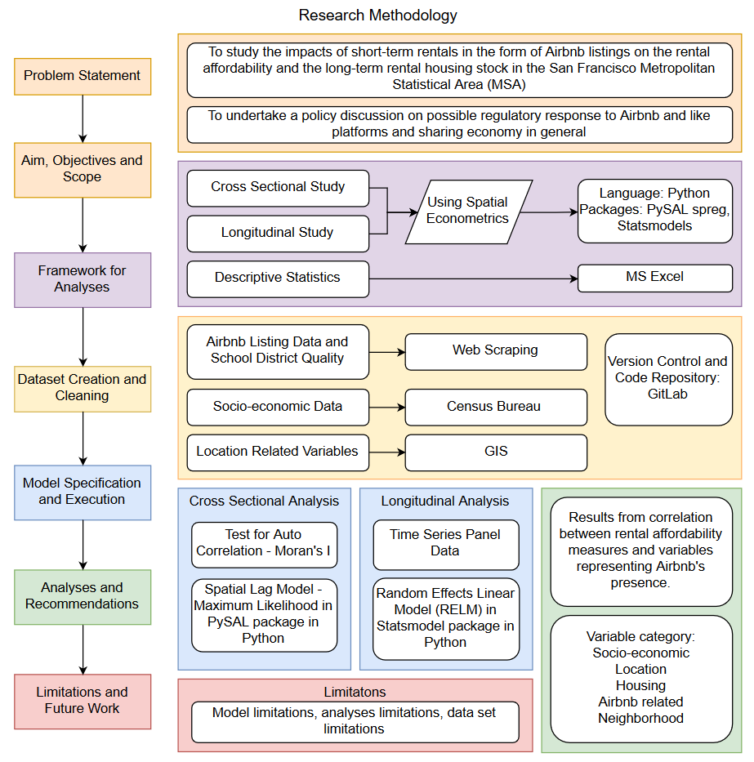

For the purposes of this research, both cross-sectional and longitudinal research was conducted. The research methodology presented in the figure above shows the steps that were undertaken and details of those steps. As shown in the figure, analyses were divided into two main sections—the cross-sectional analysis and longitudinal. A detailed treatment of these analyses is carried out in Chapters 3 and 4.

# LITERATURE REVIEW

This chapter outlines two main sections of the literature review which were undertaken during this study. The first section is about understanding the existing body of literature on sharing economy, the Airbnb disruption and housing affordability crisis in general. These include perspectives from the tourism industry, housing rent, and affordability studies, impacts on evictions etc. However, it is evident that this body of literature is still sparse and in need of more qualitative and quantitative research, especially with respect to conclusive policy and regulatory actions. The second part of the review focuses on methods and models examining mainly revolving around the application of spatial autoregressive models like spatial lag models and random effects mixed linear models for panel data etc.

## The Sharing Economy

The sharing economy is an established disruption in the current housing and tourism market dynamics. The model finds its strength in numerous merits like bottom-up, using under-utilized or latent resources – space, in this case, based on technological platforms and fostered in peer to peer connections.

The sharing economy finds its roots in many traditionally prevalent practices since the dawn of the millennium. The concept of ‘car sharing’ was launched for the first time in 1948 in Zurich and was very popular in Northern Europe in the 1980s. It was facilitated and operated by many small and community-based not-for-profit cooperatives in that era (Shaheen et al., 1999). With the advent of digital tech and Internet, information transmissions costs plummeted and coordination costs for sharing activities dropped correspondingly. This triggered a boom in online sharing activities, lifting them out of the community and into the realm of big business. Consequently, it led to concerns about their impact in all ways including the conflictual ones. Peer-to-peer (P2P) sharing activities now compete with the formally organized economic transactions and pose a challenge for existing regulatory provisions. This puts pressure on platform services providers and policy makers to provide an appropriate response to these challenges (Martens et all., 2016).

The ‘sharing’ platforms have entered in many major sectors of the economy such as transportation, accommodation, retail, office space and logistics, finance and consumer credit, and the labor market. They function on factor markets (capital, labor) and product markets (goods and services), and therefore affect the entire economy (Codagnone, 2016). There exists a debate split between supporters and opponents of the sharing economy model, and both groups use contrasting rhetoric, fueled by the bans of operation imposed by judges in various cities and violent protests of taxi drivers in response to these bans. Actual evidence, however, is very limited and inconclusive (Martens et all., 2016). Additionally, there exists a lack of data and information sharing like non-disclosure of metrics used by such platforms etc. Parallel to the aforementioned debate, platforms like Uber and Airbnb are flooding the public debate with their own reports of the positive impacts they allegedly have on cities' economies in the US and in Europe. However, one change that can be noted is that these optimistic and utopian narratives have now started to be substituted by accounts of legal disputes and the ‘dark side of the sharing economy’(Malhotra & Van Alstyne, 2014).

Figure 2 shows the life cycle of various start-ups and sectors that enter the market with the model of sharing economy and reach to the levels of decline or rebirth. While this is how the market dynamics work, an essential element which is not reflected in the graph is the impact of regulation on the life cycle of such platforms. The peer to peer sharing model often finds itself in a grey area of regulation like in Airbnb's case. The difference between Airbnb and its traditional

counterparts – hotels – have been the bone of contention for many lawsuits. While hotels are subjected to specific taxes, sanitation department checks etc, Airbnb rentals depending upon the country and state they are in, do not necessarily have such checks on them. Hence a recurring debate emerges is the idea of regulations which makes it imperative to ascertain its impacts both good and bad.

Figure 2 Sharing economy sectors in the industry life cycle

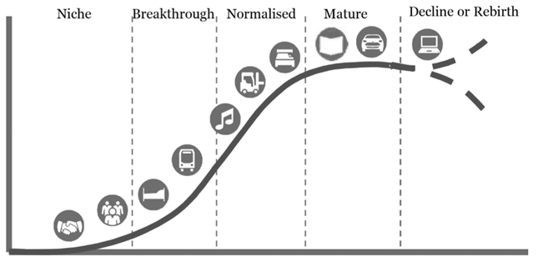

Source: The sharing economy: How will it disrupt your business?

PricewaterhouseCoopers (PwC) report, (2014)

## Airbnb disruption

Airbnb provides a platform through which both owners or lease-holders can rent out anything from a spare couch to a private room or an entire apartment, with Airbnb collecting a ‘host service’ from hosts and ‘guest service’ fees from customers for each transaction. The incentive for hosts is that they are provided with insurance from Airbnb which makes it a safe bet for them to share their houses with strangers. Additionally, the platform uses effective branding like ‘live like a local’ and ‘belong anywhere’ along with highly competitive and low rates as compared to its traditional counterparts like hotels and motels. With such strategies, Airbnb has been able to penetrate in more than 191 countries around the world and has now become an established disruption in the tourism and housing market around the world. Evidently, Airbnb enables some hosts to pay their house loans and earn extra income from an underutilized section of their home. However, this is also a place for professionals listing their entire properties (sometimes entire apartment blocks) to Airbnb. Additionally, complaints have increased regarding the negative externalities such as noise and trash generation that Airbnb listings can produce in neighborhoods. In a high-profile lawsuit against Airbnb in New York, the New York Attorney General’s report was critical of the fact that six percent of hosts seemed to be “commercial users” in that they accounted for 36% of all private short-term bookings[4]. In 2014, Airbnb listings in New York state were deemed “mostly illegal” based on building and safety codes and tax regulations violations (Streitfeld, 2014). Despite the lack of literature and comprehensive studies, regulatory responses have been observed, such as the city of Barcelona, which has cracked down on Airbnb with new fines and regulations (O’Sullivan, 2015). A closer look is needed to understand the nature of such platforms to ascertain their impacts. The table presented below summarizes the learnings from the papers reviewed for the literature study.

Table 1 Learnings from literature review of selected papers and reports

|  |  |  |
| --- | --- | --- |
| **Author, Year** | **Notes and Learnings** | |
| **Stulberg (2016), FiveThirtyEight** | * The study correlated rents in urban centers with demand for Airbnb listings in the US using combined revenue in dollars per neighborhood. * Concluded that Airbnb was not responsible for driving up rent but recognized an eventual possibility. The methodology and the data used are not publicly available, as the author used AirDNA, a paid data service. * AirDNA was utilized in this thesis also. I used the county-level average revenue figures that are available for free to inquire into revenue potential of Airbnb. | |
| **Dayne Lee (2015), Harvard Law & Policy Review**  Table 1 (cont.) | | * This paper utilized a series of non-regression methods to determine correlation between rent increase and Airbnb listings in Los Angeles. * It employed a per-neighborhood analysis of Los Angeles housing market and concluded that rent increase can be associated with Airbnb. * While the analysis does not consider spatial autocorrelation, it still serves as an important reference in research on the subject. Most importantly, the paper provides an articulate theory on Airbnb’s role in the housing market. | |
| **Giovanni Quattrone**  **et. al. (2016)** | * This paper used a multivariate OLS regression to compare demand for Airbnb to various demographic and economic indicators in London. * A key takeaway was the stark difference in the categories of Airbnb listing per neighborhood. Highly educated and low-income areas (university student neighborhoods) provided more sharing listings, while suburbs tended to have more expensive commercial listings. * These differences matter in analyzing potential effects on housing markets, as any market distortion would come from the ‘elite class’ of property owners but will impact the low-income markets more. | |
| **Hooijer (2016)** | * This paper studied the correlation between tourism industry and Airbnb’s presence, showing a negative relationship between hotel revenue and number of Airbnb listings. * The study controlled for population and unemployment rate. * The author also introduced the unemployment rate as a potential control, which significantly altered the result compared to the other regressions that were conducted. | |
| **Zervas et. al. (2012)** | * This paper used spatial analysis model comparing hotels and Airbnb listings to demographic and economic data sourced from the US Census Bureau to analyze the impact of Airbnb on hotel revenue in Austin, Texas.   Table 1 (cont.)   * The study found that hotel prices and revenues are not affected by competition from Airbnb. Instead it listed the impact as a loss of flexibility for the hotels to increase charges in peak season. * A major takeaway was the understanding of the stale listing problem which is why this thesis included the differentiation of active listings and all listings. | |
| **Gurran et. al. (2017)** | * This paper studied the proliferation of short-term rental accommodations in the Sydney metropolitan region, with a special focus on implications for urban policy and planning. * The paper concluded that Airbnb rentals can potentially generate neighborhood impacts that require a new land use planning response, create pressure on the permanent rental housing supply or offer ﬂexible income to help hosts make their own homes more affordable. | |
| **Sheppard and Udell (2016)** | * This paper attempted to estimate the impacts that Airbnb listings have on the value of residential properties in New York City. * It found that an increase in Airbnb listings can be associated with an increase in property values. * The paper used a hedonic model to estimate that the doubling of such listings can be associated with an increase of 6 - 11% in house prices (ceteris paribus). It also noted that properties that Airbnb listings experience an increase in value by 31%. | |
| **Baron, Kung (2017)** | * This is a working paper that aims to assess the impact of home-sharing on residential house prices and rents. * The study utilized Airbnb listings dataset from the entire US and an instrumental variables estimation strategy to conclude that a 1% increase in Airbnb listings results in 0.018% increase in rents. * This effect is moderated by the share of owner-occupiers, a result consistent with absentee landlords reallocating their homes from the long-term rental market to the short-term rental market. | |
| **Policy Analysis Report by Budget and Legislative Analyst, San Francisco (2015)** | * This report was requested by the City and County of San Francisco office to conduct an analysis of how short-term rentals affect the housing market in San Francisco. * It also provided an overview of the Planning Departments short-term rental enforcement efforts and how they might be made more effective. * The report listed various statistics of the listings and mentioned at the enforcement of regulations will be difficult due to non-reporting and missing data about the listings. * They suggested acquisition of data from Airbnb for improved investigation methods. | |

Table 1 (cont.)

## Housing Affordability

Shelter is a basic human need and is necessary for survival. A considerable number of people in the US suffer from lack of affordable housing and housing security. Affordability crises plague most major US cities and the housing insecurity that comes with it can lead to several problems like significantly poorer well-being, poor physical, restricted social networks and even barriers to education and employment (Skobba and Goetz; Long, Rio, and Rosen). Additionally, housing accounts for a substantial share of household budgets, beating transportation costs, food and health care costs in most cases. In 2017 housing expenditure (mortgage payment or rent) accounted for a total of 19.2% of total consumer expenditures and 25.8% for renters among US households (US Bureau of Labor Statistics, Consumer Expenditure Survey 2015). The cost increased significantly with the inclusion of utilities and taxes. Hence the situation is dire, and while it is imperative to increase the affordable housing stock, it is equally important to ensure that the existing housing is not pushed away from being affordable. Loss of rental housing and decreased rental affordability is one facet of this problem. Every lost long-term rental unit (which could have been leased out for one year or more) can potentially exacerbate the problem especially in a city like San Francisco where owning a house is an extremely costly affair.

Hence, while the world sees the advent of the sharing economy platforms, another reality is that of the housing affordability crisis. Attractive cities in the United States are experiencing housing shortages at unprecedented rates. The National Low-Income Housing Coalition (NLIHC) uses the housing wage method to compute the housing and rental affordability of regions. According to its recent estimates, the statewide minimum wages do not cover the housing costs of a two-bedroom unit within all 50 states in the US.

Figure 3 Affordability trends in San Francisco MSA for 2010 - 2016

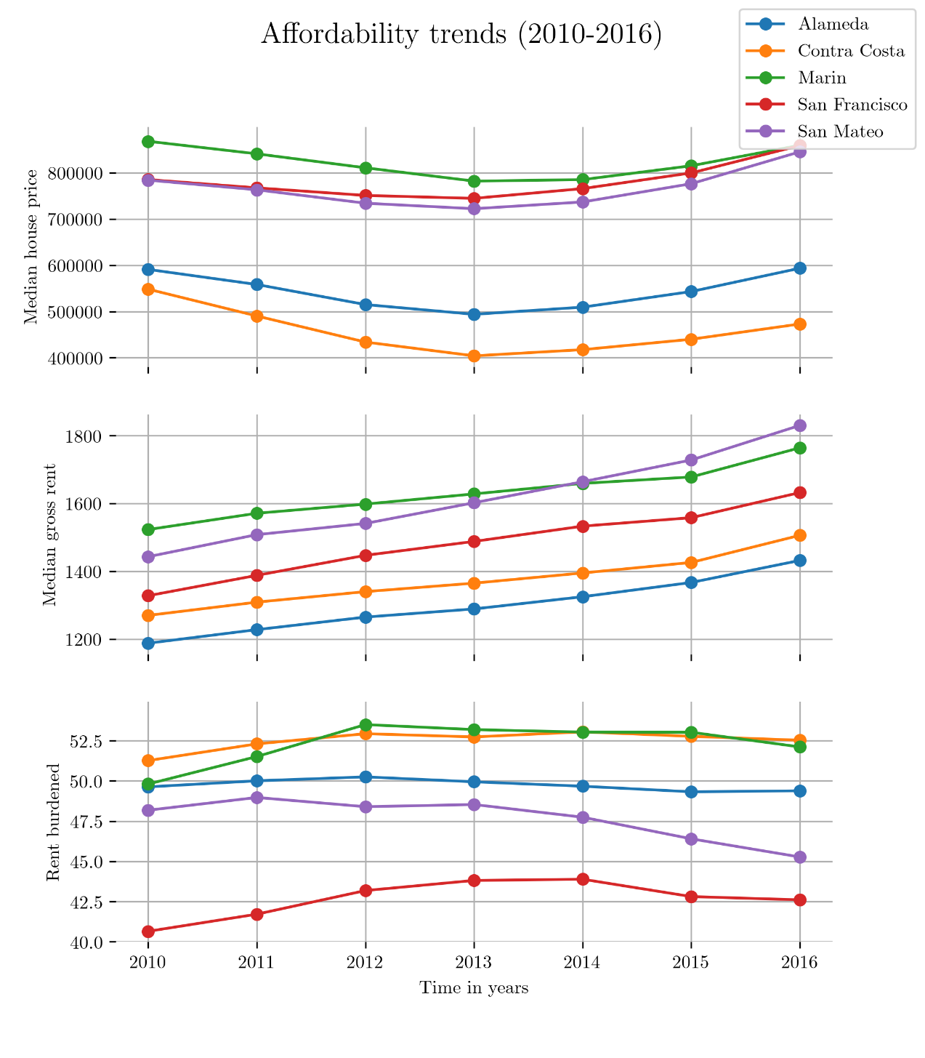

Unsurprisingly, California is facing acute housing affordability crisis and cities like San Francisco frequently rank high on the most unaffordable cities lists. NLIHC states that to afford a two-bedroom unit in San Francisco, on average, there is a requirement of 114 hours of minimum wage work per week (Aurand, 2016). Figure 3 shows the increasing trends of median rents and house price values in MSA (5 county region) along with percentage rent burdened households. There are multiple, complex issues and phenomenon at play leading to such a situation. The shortage of housing supply is just one aspect of it. Residents increasingly get outpriced out of neighborhoods due to various public and private interventions. In the rental housing market, another contributor to the crisis is the loss of long-term housing stock. While the quantification of the extent of the loss due to the short-term rentals is up for debate and a subject of research, it is increasingly becoming clear that Airbnb-like platforms, can provide a lucrative income-generating options to its hosts.

## Spatial Econometrics

The literature research on the spatial econometrics methods was mostly around the works of Luc Anselin and Sergio J.Ray. In the book titled “Modern Spatial Econometrics in Practice”, the aforementioned authors provide a definitive user’s guide to the spatial regression functionality in various software packages like GeoDa, GeoDaSpace and spreg module in PySAL library in Python–all developed at the GeoDa Center for Geospatial Analysis and Computation. The book[5] provided the techniques to test for and estimate spatial effects in linear regression models, addressing both spatial dependence (spatial autoregressive models) as well as spatial heterogeneity (spatial regime models). The book and recorded videos were key sources for the development of the spatial lag model and random effects linear model used for this research. R programming language was also used to run the selected models and to generate LaTeX outputs of the results. The understanding of the relationship of Airbnb with housing and tourism sectors is an emerging body of literature.

Overall, the readings not only provided similar theories of the impacts of Airbnb but also provided results that suggested a clearer path forward – a comprehensive spatial econometric analysis of Airbnb’s presence and the rental housing market. Crucially, even the papers that concentrate more on tourism and the hotel industry than residents and gentrification provide valuable insights into the use of Airbnb data along with census data.

# DATA AND METHODS

As mentioned in the chapter 1, this study conducts both cross-sectional and longitudinal analysis. This chapter details out the methods used, the theory behind those methods, dataset generation, our unit of analysis and the variables considered. It is important to note here that the cross-sectional analysis was carried out for the San Francisco MSA (a five-county region) whereas the longitudinal analysis was carried out for San Francisco city due to limited availability of data on Airbnb listings.

## Cross-sectional Analysis

The cross-sectional analysis was carried out to provide information on the characteristics of and statistical relationships between selected dependent and independent variables, at a specific moment in time – 2017 for this research.

Study Area

The chosen area for the cross-sectional study was the San Francisco-Oakland-Hayward MSA (Metropolitan Statistical Area) which is a five-county region in California with a population of 4,679,166 (2016 ACS estimate) and an area of 2,474 square miles (6,410 km2). It consists of Alameda County, Contra Costa County, San Francisco County, San Mateo County, and Marin County. To better gauge the extent of spatial correlation and expand the analysis, the MSA area was selected so as to not confine the analysis to San Francisco City. This five-county area includes major urban centers as well as suburban development and few rural areas. This diversity also helped in understanding the impact of Airbnb listings beyond just a city/urban area. Figure 4 shows the five-county study region and Airbnb listings in it.

Figure 4 Airbnb listings in San Francisco MSA as of 2017

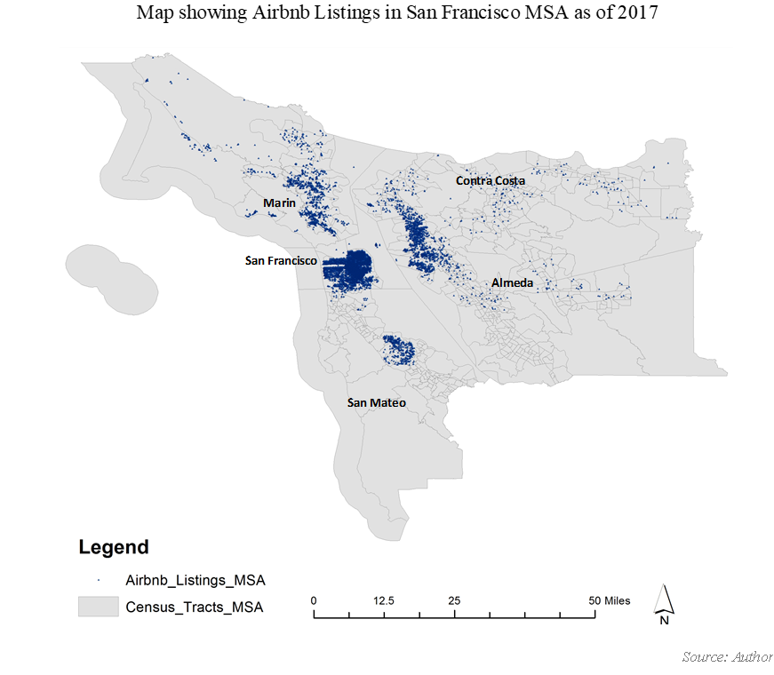

## Dataset Generation

For the purposes of dataset creation, various methods were used to collect relevant data. For the Airbnb listing data, a script[6] was developed in Python using selenium and PostgreSQL packages to scrape data off of airbnb.com. The scraping was undertaken for all five counties in the study area and listings data was extracted with their location coordinates using the bounding box method. The scraping was undertaken in December 2017. In addition to using Airbnb listings as a percentage of rental housing units[7], a composite score index was created which incorporated the difference of listing type. A weight of 1 was given to entire house listings, 0.5 for private rooms and 0.2 for shared rooms/couches etc. The distribution of percent Airbnb listing and weighted listings indicate positively skewed distributions as shown in the figure below. Hence to account for heteroskedasticity, all variables used in the model are natural logarithms (except the dummy variable) were log-transformed.

Figure 5 Distribution of Airbnb listings in the study area



Data for independent (control) variables like *log percent unemployed population, log percent foreign-born population, log percent non-white population, log rent burdened households* and *log rent overburdened households* was obtained from the American Community Survey, using 2016 estimates for the study area. This data was collected at the census-tract level.

Another independent variable in the dataset is *log school district quality* which is in the form of a score assigned by an independent non-profit—greatschools.org. The school quality is reflected from a score called summary rating that the website gives based on various criteria. According to the nonprofit, the summary rating is a multi-measure school quality metric intended to reflect a school’s characteristics and quality across multiple dimensions, ultimately representing the school’s overall quality in preparing students for postsecondary success. It is an aggregation of the school’s ‘sub-ratings,’ which include test score, student progress, academic progress, equity, college readiness, and advanced courses ratings, as well as a flag for discipline and attendance issues[8]. The data for this variable was web-scraped from the greatschools.org website using a Python script[9]. The centroids of the census-tracts were used as address/locations for all schools in that census-tract. The highest school quality score was selected in case of multiple schools existing in the same tract. There was an element of reverse geocoding the location coordinates of the census tract centroids by using Google API to create addresses that the greatschools.org website accepts for locating relevant schools at the high school level.

For the location variables like *Log BART dist* (log of Euclidian distance of BART stations from census-tract centroid), *Coastline tracts* (dummy variable where 1 denotes a coastline tract) and *Log CBD dist* (log of Euclidian distance between nearest central business district and centroid of the census-tract) were computed using ArcMap in ArcGIS and its functions in ArcToolbox and network analyst.

For gauging job accessibility, two variables from the Smart Location Database were used. The primary variables – D5ar & D5br from the destination accessibility dataset were used because they measure jobs or working- age population within a 45-minute commute via automobile (D5ar) or transit (D5br). The “r” reflects the accessibility of job from residences to jobs. This data was collected at the census-tract level for all five counties in the study area. Table 2 shows the variable categories and description in brief.

Table 2 Brief description of variables used in cross-sectional analysis (spatial lag model)

|  |  |  |  |  |
| --- | --- | --- | --- | --- |
| **Variable Category** | **Variable Name** | **Description** | **Data Source** | **Remarks** |
| **Independent Variables** | | | |  |
| **Airbnb** | Log Percent Airbnb | Log of Airbnb listings as a percentage of rental housing units | Airbnb.com web scrape & US Census TIGER/Line Files |  |
| Log Weighted Airbnb listings | Log of weighted Airbnb listings (1 for entire home, 0.5 for private room, 0.2 for shared room) | Airbnb.com web scrape |  |
| **Location** | Log BART dist | Log Euclidean distance in meter between census tract centroid and nearest BART station | ArcMAP analysis & TIGER/Line shapefiles from Census Bureau |  |
| Log CBD dist | Log Euclidean distance in meter between census tract centroid and nearest Central Business District | ArcMAP analysis & TIGER/Line shapefiles from Census Bureau |  |
| Coastal tracts (Dummy) | if a census tract is at the coast line; otherwise 0 | ArcMAP analysis & TIGER/Line shapefiles from Census Bureau |  |
| **Demographic** | Log unemployment rate | Log of percentage unemployed people as a percentage of the civilian labor force | US Census TIGER/Line Files |  |
| Log percent non-white  Table 2 (cont.) | Log of percentage population which is not white | US Census TIGER/Line Files |  |
| Log percent foreign-born | Log of percentage population who is not US citizen at birth, includes those who become US citizens through naturalization | US Census TIGER/Line Files |  |
| **Neighborhood Level** | Log school district quality | Log of school district score as given by greatschools.org | Greatschool.org web scrape |  |
| **Job Accessibility** | Log accessibility by car | Log of jobs within 45 minutes auto/car travel time; time-decay (network travel time) weighted | Smart Location Database, US EPA Smart Growth Program |  |
| Log accessibility by transit | Jobs within 45-minute transit commute, distance decay (walk network travel time) weighted | Smart Location Database, US EPA Smart Growth Program |  |
| **Dependent Variable** | | | |  |
| **Rental Affordability Measures** | Log rent burdened | Log of percentage households spending 30% or more of gross monthly income towards total housing costs | US Census TIGER/Line Files | Inversely related to rental affordability |
| Log rent overburdened | Log of percentage households spending 50% or more of gross monthly income towards total housing costs | US Census TIGER/Line Files | Inversely related to rental affordability |
| **Housing variables** | Log median rent | Log of median gross rents or monthly housing cost expenses for renters | US Census TIGER/Line Files | Inversely related to rental affordability |
| Log median house price | Log of median house prices | US Census TIGER/Line Files | Inversely related to rental affordability |

Table 2 (cont.)

## Methods

For the purpose of this analysis, spatial econometrics was used. Spatial econometrics is a subfield of econometrics that deals with spatial interaction (spatial autocorrelation) and spatial structure (spatial heterogeneity) in regression models for cross-sectional and panel data (Paelinck and Klaassen, 1979; Anselin, 1988a). It is used in theoretical models which involve interactions between different entities and for models with data observations which are not truly independent due to spatial auto-correlations and neighborhood effects. Figure 6 shows the step by step diagnostic flowchart of arriving at an appropriate model for a cross-sectional analysis.

The data was tested for spatial correlation using the Moran’s I test, before proceeding with regression analysis to understand the correlation between rental affordability and Airbnb’s presence. As expected, the data tested positive for spatial autocorrelation. Chapter 4 contained the details of the test for spatial autocorrelation and also contains a report for Global Moran’s I. Hence the focus of the quantitative analysis was to undertake spatial analysis on the principles of spatial econometrics. The spatial lag model can be written as:



where $y$ is an $n×1$ vector of observations on the dependent variable, $W$ is an $n×n$ spatial lag operator and $Wy$ is a spatial lag term with spatial auto-regressive parameter $ρ$, $X$ is an $n×k$ matrix of observations on exogenous (independent) explanatory variables with $k×1$ coefficient vector $β$, and an $n×1$ vector of errors $u$.

For this analysis, Maximum Likelihood (ML) approach was used in conjunction with the aforementioned spatial lag model. ML does not allow for the presence of multiple endogenous (dependent) variables for the model specification. For our analysis, a single independent variable suffices. ML approach assumes homoskedasticity of the error term $u$.

Figure 6 Steps undertaken for diagnostics of spatial specifications

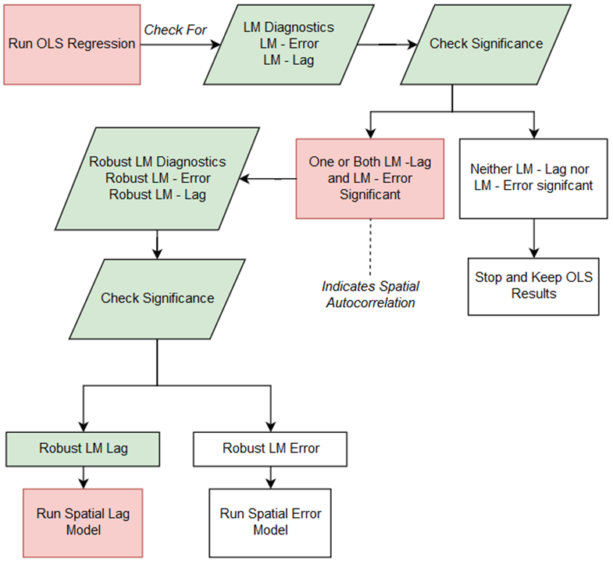

For easier understanding, the model can be thought of in the following way:

* A shapefile is used to construct a spatial weights matrix (which assigns weights based on *k* nearest neighbors for each unit of analysis i.e. census-tract). In this model k was chosen to be 4, meaning each census-tract is assumed to be impacted by 4 nearest census-tracts around it.
* A log-likelihood variable can be defined as a function of parameter: *β, ρ*, and *σ2*, where *σ2* is the variance of the error distribution.
* The ML estimates for these three parameters are found by equating their first derivatives to zero and solving the resulting equations.
* Finally, the maximum log-likelihood can be computed by numerically estimating the single parameter ρ. These steps were carried out with the help of spdep and car packages in R. Chapter 4 details out the results obtained from these computations.

## Longitudinal Analysis

Longitudinal analysis is the study of short sets of observations obtained from multiple data points over time, also referred to as panel data analysis. In econometrics, panel data is essentially a multi-dimensional dataset that contains data points over time. The data contains observations of multiple phenomena obtained over multiple time periods for the same firms or individuals or in this case, Airbnb listings.

Study area

The study area for this analysis was the San Francisco city. This was due to data availability constraints. While I would have preferred to use MSA as out study area, the scraping of the website for older listings (2013 to 2015) was not possible due to lack of archived data. Hence the construction of panel data was not possible for the whole MSA. Instead, panel dataset is created using the web scraped listing data for San Francisco city created by Tom Slee.

Figure 7 Proliferation of Airbnb listings from 2013 to 2016

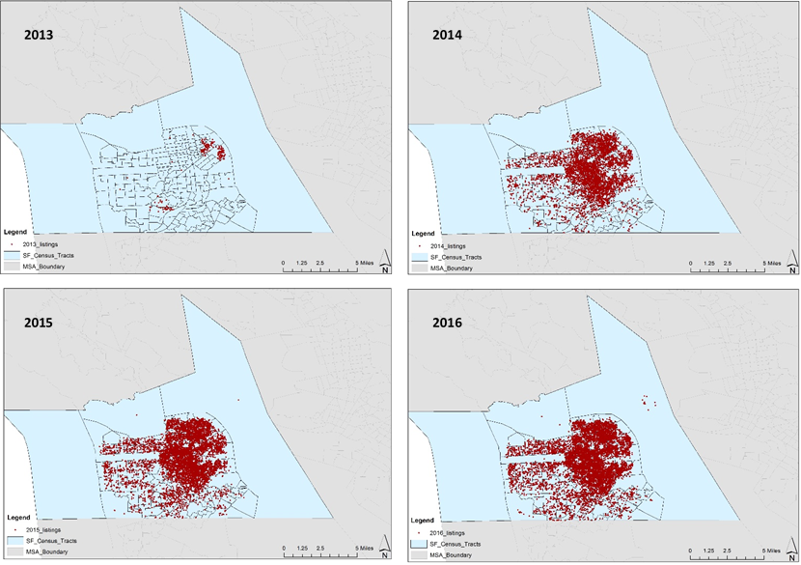

## Dataset generation

The dataset for this analysis was generated using two main data sources and the use of ArcMap in ArcGIS. The first data source was the census bureau and ACS estimates for a four-year period of 2013-2016. Demographic variables namely – *log percent population with bachelor’s degree or higher, log percent unemployed population, log percent foreign-born population, log percent non-white, log rent burdened,* and *log rent overburdened* were collected from the 2016, ACS 5-year estimates. In addition to these the location variables like *Log BART dist* (Euclidian distance between BART stations and census-tract centroid), *Coastline tracts* (dummy variable where 1 denotes a coastline tract) and *Log CBD dist* (log of Euclidian distance between nearest central business district and centroid of the census-tract) were computed using ArcMap in ArcGIS and its functions in ArcToolbox and network analyst.

A ‘*trend*’ variable is also included in the model to account for year effects (also known as “year dummies” or “dummies for each of the years in a dataset”) i.e. to capture the influence of aggregate (time‐series) trends. In our case values from 4 to 1 are given to years 2016- 2013.

For the Airbnb listings data, the dataset created by Tom Slee of Inside Airbnb and made available at GitHub was used. This data was scraped for 2012-2016 which included the listing locations and availability. We can safely ignore the location variables as they do not change as a function of time and hence do not affect the fitting of the linear mixed effects model. Figure 7 shows the Airbnb listings from 2013 to 2016 used for the analysis. The table 3 gives a brief description of the independent and dependent variables.

Table 3 Brief description of variables used in longitudinal analysis

|  |  |  |  |  |
| --- | --- | --- | --- | --- |
| **Variable Category** | **Variable Name** | **Description** | **Data Source** | **Remark** |
| **Independent Variables** | | | |  |
| **Airbnb** | Log Percent Airbnb all rentals | Log of Airbnb listings as a percentage of all rental housing units | Airbnb.com web scrape & US Census TIGER/Line Files |  |
| Log Percent Airbnb Active rentals | Log of Airbnb listings as a percentage of active or occupied rental housing units | Airbnb.com web scrape & US Census TIGER/Line Files |  |
| **Location** | Log BART dist | Log Euclidean distance in meter between census tract centroid and nearest BART station | ArcMAP analysis & TIGER/Line shapefiles from Census Bureau |  |
| Log CBD dist  Table 3 (cont.) | Log Euclidean distance in meter between census tract centroid and nearest Central Business District | ArcMAP analysis & TIGER/Line shapefiles from Census Bureau |  |
| Coastal tracts (Dummy) | if a census tract is at the coast line; otherwise 0 | ArcMAP analysis & TIGER/Line shapefiles from Census Bureau |  |
| **Demographic** | Log percent bachelor’s degree | Log of percentage population holding a bachelor’s degree or higher | US Census TIGER/Line Files |  |
| Log percent foreign-born | Log of percentage population who is not U.S. citizen at birth, including those who become U.S. citizens through naturalization | US Census TIGER/Line Files |  |
| Log unemployment rate | Log of percentage unemployed people as a percentage of the civilian labor force | US Census TIGER/Line Files |  |
| **Time effects** | Trend | Value of 4 to 1 given to years 2016 -2013 | author |  |
| **Dependent Variables** | | | |  |
| **Rental Affordability Measures** | Log rent burdened | Log of percentage households spending 30% or more of gross monthly income towards total housing costs | US Census TIGER/Line Files | Inversely related to rental affordability |
| Log rent overburdened | Log of percentage households spending 50% or more of gross monthly income towards total housing costs | US Census TIGER/Line Files | Inversely related to rental affordability |
| **Housing variables** | Log median rent | Log of median gross rents or monthly housing cost expenses for renters | US Census TIGER/Line Files | Inversely related to rental affordability |
| Log median house price | Log of median house prices | US Census TIGER/Line Files | Inversely related to rental affordability |

Table 3 (cont.)

## Methods

For longitudinal analysis in this study we consider the Mixed Linear Model (sometimes also referred to as linear mixed effects model in literature). We implement a model with random intercepts (i.e. random coefficients) using a formula:



where $Y_{ij}$ is the jth measured response (dependent variable) for group i, $X_{ij}$ is a covariate (independent variable) for this response, are the fixed effects parameters shared by all groups, the ’s are the random effects parameters tailored to each group and are errors, independent of everything else and identically distributed.



In our case, observations for each year constitute a group (i.e. individual being a census tract) and hence we have 4 groups (2013, 2014, 2015 and 2016). Because of their advantages in dealing with missing values, mixed effects models are often preferred over more traditional approaches such as repeated measures ANOVA (analysis of variance). Panel data analysis was undertaken using the spdep, plm and Ecdat packages in R along with some preliminary investigations done in statsmodel package in Python.

## Limitations

The attempted inquiry made in this research has limitations. Some of them are:

* Locations of listings on the Airbnb website are shifted by a certain amount to preserve privacy of the listings and only when a booking is made is the exact address shared. Hence during web-scraping, the locations scraped off the website do not denote precise location of listing. A probability model can increase the accuracy to a certain extent instead of the bounding box method used in this analysis.
* Study area for longitudinal analysis is not the same as the cross sectional one due to lack of available data.
* The process of web-scraping itself was a weeklong exercise and so any changes in active listings between the same locations within that week might not be incorporated.
* Use of census-tract centroid as proxy for calculating location variables like Bart distances etc. is a crude approximation. In addition to that the use of the Euclidian distance method for the CBD and BART distances also runs the risk of oversimplification.
* The dataset used for both cross-sectional and longitudinal analysis can include more independent (control) variables which can make the models more robust.
* The study does not exhaustively cover the possible impacts of Airbnb on the housing market. There are multiple spillover effects of home sharing need more localized qualitative approach.

Chapter 4 details out the results obtained from these computations within the aforementioned limitations.

# RESULTS

This chapter presents the results of the cross-sectional and longitudinal analysis carried out by using the models described in the last chapter. One of the first steps for both cross-sectional and longitudinal analyses was the test for autocorrelation. Spatial autocorrelation is an integral concept in spatial statistics as it enables the investigation for spatial interpolation. Simply put, Spatial autocorrelation is a measure of similarity or correlation between nearby observations. To test for spatial autocorrelation, the Moran’s I test was conducted. Moran’s I test suggests that:

* -1 is perfect clustering of dissimilar values or perfect dispersion
* 0 is no autocorrelation or perfect randomness and
* +1 indicates perfect clustering

Moran’s I is an inferential statistic and hence there is a need to assess whether the index generated is significant or not. This is done with a simple hypothesis test of calculating z-score and its associated p-value.

* The null hypothesis for the test states that data is randomly disbursed.
* The alternate hypothesis states that it is more spatially clustered.

Two possible scenarios then become that positive z-value will mean that the data is spatially clustered whereas a negative z-value will mean that the data is clustered in a competitive way. For example, high values are repelling high values or negative values are repelling negative values. Table 4 shows the Global Moran’s I test report generated on the percent Airbnb listing dataset and the results show that there is clustering, and hence spatial autocorrelation is significant and present. Hence a simple OLS regression for the dataset will not yield credible results and there is a need to use models that account for the spatial autocorrelation for both the cross-sectional and longitudinal analysis.

Table 4 Global Moran's I test for spatial autocorrelation



Following a positive test for spatial autocorrelation, the following results were obtained from the cross-sectional analysis. The study area is the San Francisco MSA and as mentioned earlier and all variables are natural logarithms used to tackle the issue of heteroskedasticity. Table 4 summarizes the results from spatial lag model used in the cross-sectional analysis. The table shows eight models which are varying combinations of independent and dependent variables. Each model is a combination of one of the rental affordability measures as Y variable (*log rent burdened, log rent overburdened, log median rent* and *log house price*), and two sets of X variables (with *Log percent Airbnb listings or Log composite score* as one of the key variables along with all demographic, neighborhood level and location variables).

Table 5 Coefficients and standard errors for spatial lag models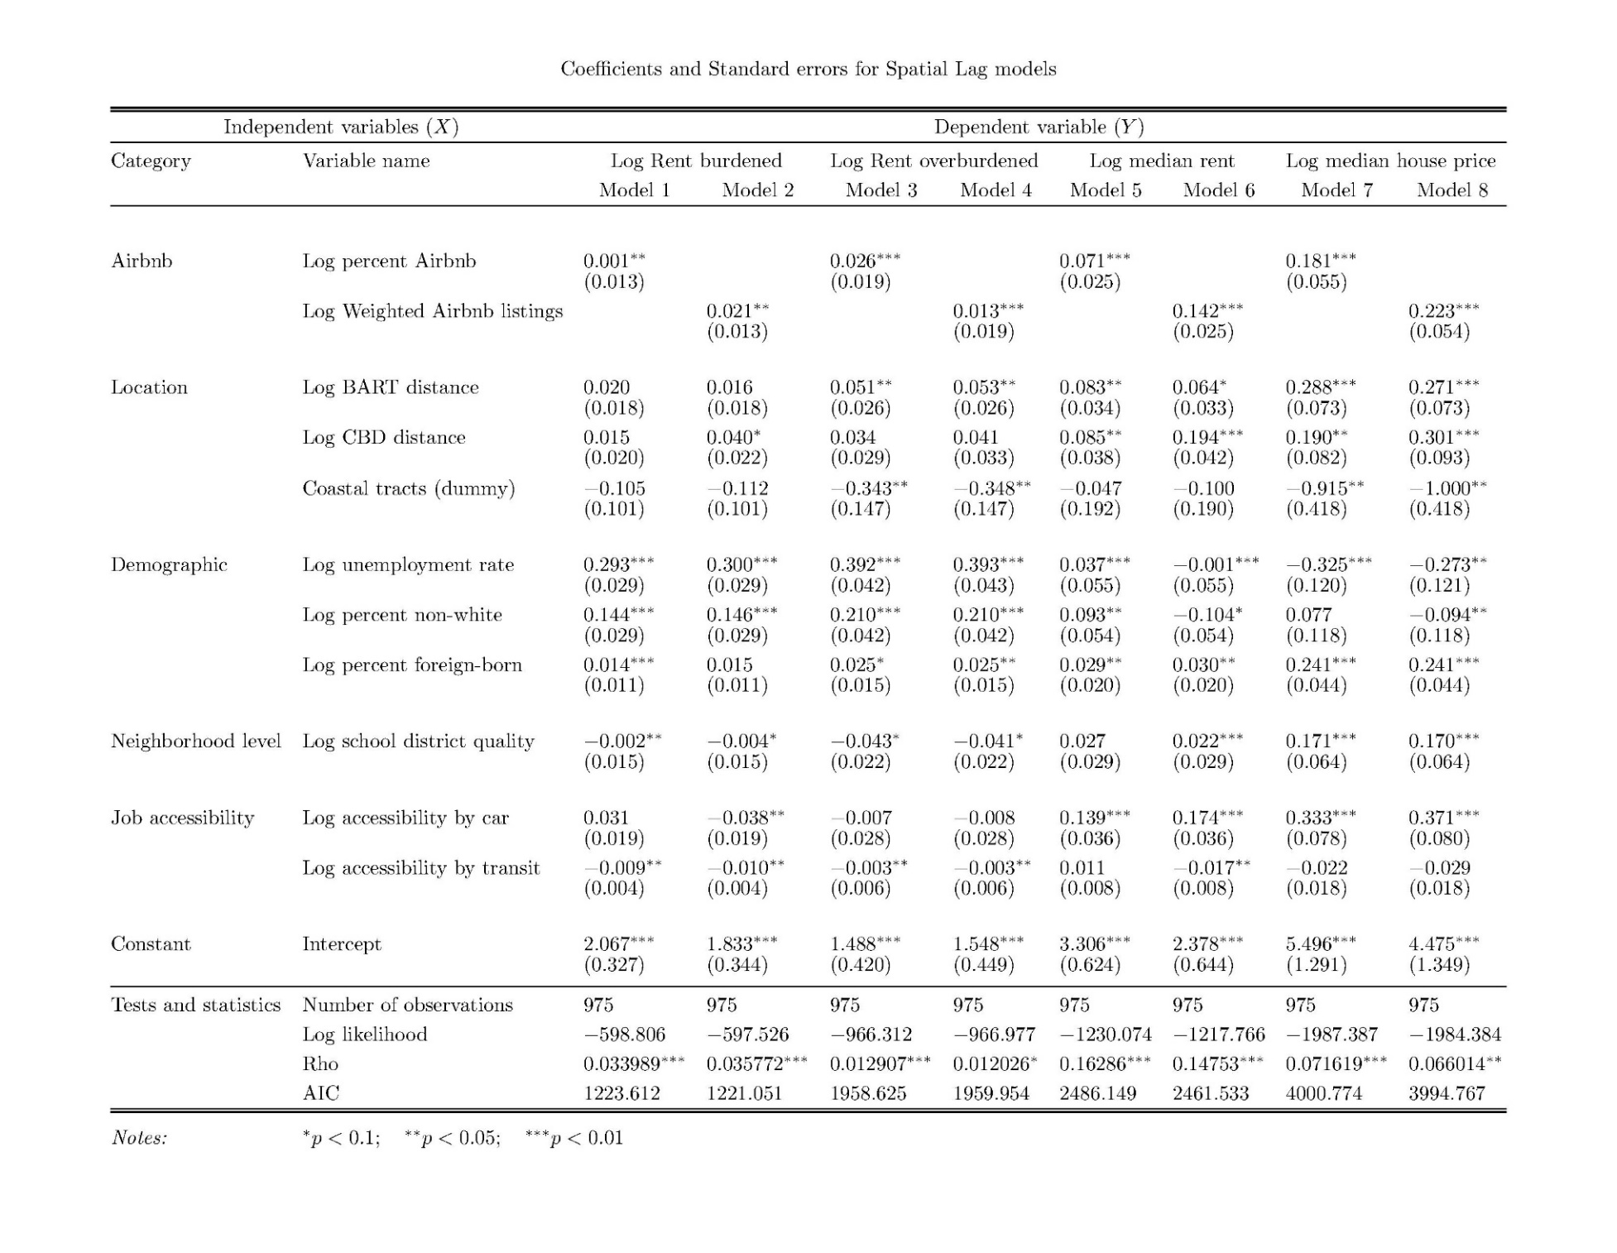

Following observations can be made from the results of the spatial lag model. To interpret the models, I pay attention to Probability values (should be p < 0.1 for a significant correlation), Coefficient values to ascertain the dependence of independent variable on Y.

* Both Airbnb variables (percent and weighted listings) have positive coefficient for all eight models. Additionally, they are all statistically significant.
* Location variables, log BART dist. and log CBD dist. show a positive coefficient. This is as expected since proximity to BART stations and downtown/central business districts is usually accompanied by higher rents, house prices and hence more number of rent burdened and overburdened households. The dummy location variable accounting for whether or not a census tract is on the coast shows negative coefficients for models 1, 2, 3 and 4 as expected. This can be attributed to the fact that housing in coastal tracts (with views) usually is premium housing and therefore attract only higher income groups leading to lower rent burdened households. However, models 5, 6 7 and 8 either show statistically insignificant results or counter-intuitive signs (negative). This indicates an opportunity to use more nuanced variables representing coastal locations in the study.
* All the demographic and neighborhood level variables show significant correlation and similarly show expected signs.
* The job accessibility variables show mixed results. While most of the coefficients are significant, it is hard to intuitively grasp the reason behind their signs without resorting to more detailed accessibility models.

The tests and statistics give the log likelihood and Akaike Information Criteria results. Both these statistics indicate the quality of models. A lower value of log likelihood and a larger value of AIC indicate a better-quality model. Additionally, Rho statistic is significant for all models and indicates high spatial dependence within the dataset. All the models with percent Airbnb as the independent variables show better test values than the weighted listings variables. Hence the results from these models are further simulated below for more intuitive understanding.

Figure 8 Simulations for the cross-sectional analysis

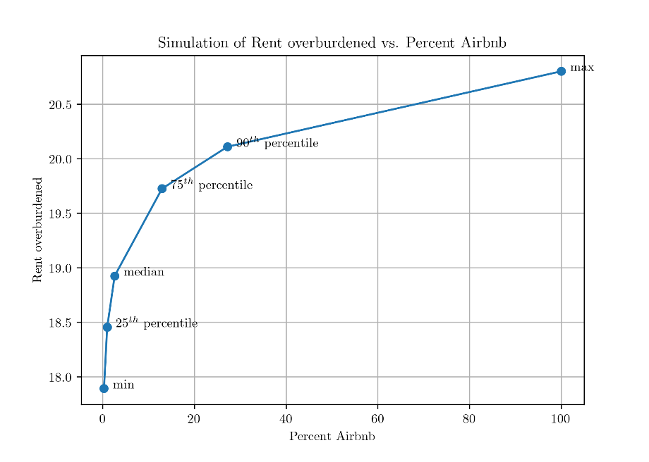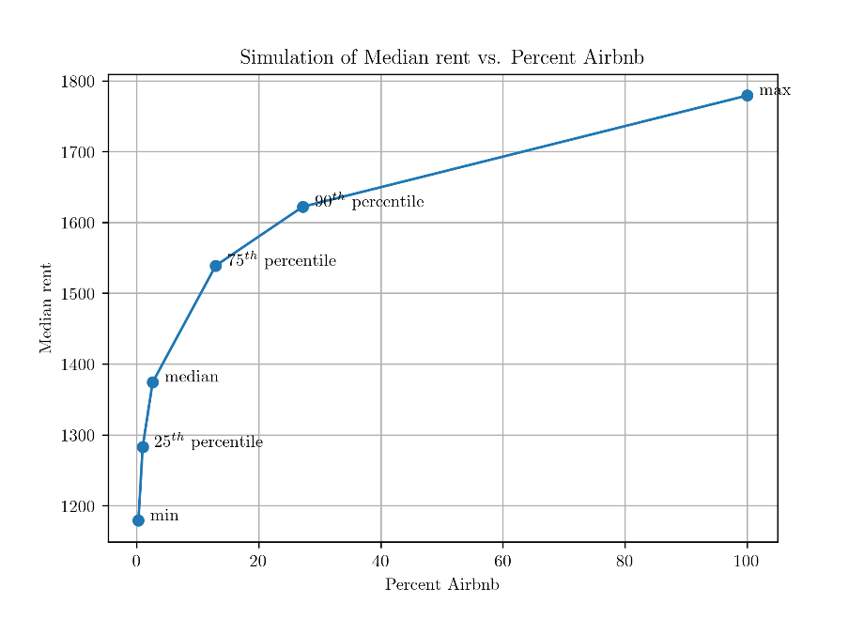

Since both the independent and dependent variables were log-transformed and fairly low in magnitude, we simulate the results by plotting values estimated by the model at the 0th (min), 25th 50th (median), 75th, 90th and 100th (max) percentile of the X variable. These simulations show that for a typical census tract (one with median percentage of Airbnb listings, as a fraction of the rental housing market) a 1% increase in percent Airbnb listings corresponded to a 0.06% rise in the rent overburdened household category. Hence, in the case of a census tract with 10,000 households, a 10% increase in percent Airbnb listings will correspond to 60 more households being added to the rent overburdened category. This effect is more pronounced for tracts with a lower number of Airbnb listings (10th or 25th percentile). This would mean that tracts with no or low percentage Airbnb listings will see more households being pushed to a rent burdened category, with similar rise in Airbnb listings.

In the case of median rents, for a typical census tract, a 1% increase in percent Airbnb listings corresponded to a $12 hike in median gross rents. For census tracts with a lower presence of Airbnb (25th percentile or lower), this number got as high as $100.

In addition to the cross-sectional study, a longitudinal analysis of panel data was also conducted and the observations from the results are given below in table 5. It is important to note here that the study area for this analysis is the San Francisco City and not the whole MSA. Hence, the unit of analysis is a census tract and the panel data accounts for a four-year period from 2013 to 2016.

* Both Airbnb variables (percent all rentals and percent active (occupied) rental housing) have positive coefficient for all eight models. Additionally, they are all statistically significant.
* Location variables like log BART distance and log CBD distances and the time effects variable – ‘trend’ in some case are not significant and in others, don’t show consistent and expected trends.
* In the case of demographic variables, percent bachelor’s degree, percent unemployed and median household income variables show significant and expected signs. However, percent foreign-born variable does not.
* The R2 values for model 1 and 2 are higher and therefore a larger part of the variation in the Y is explained by the independent variables (X) in these models. The adjusted R2 values show equivalent results.

Table 6 Coefficients and standard errors for random effects mixed linear models for panel data

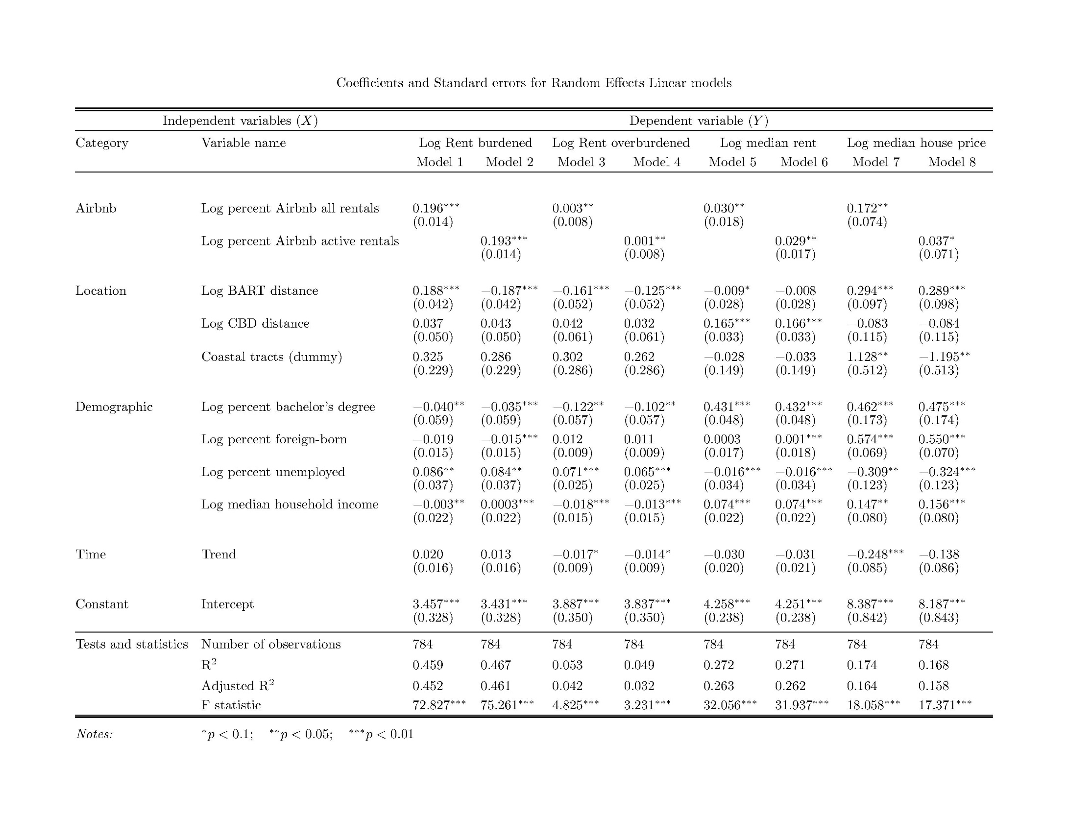

Figure 9 Simulation of rent overburdened households vs Airbnb Listings for 2013 - 2016

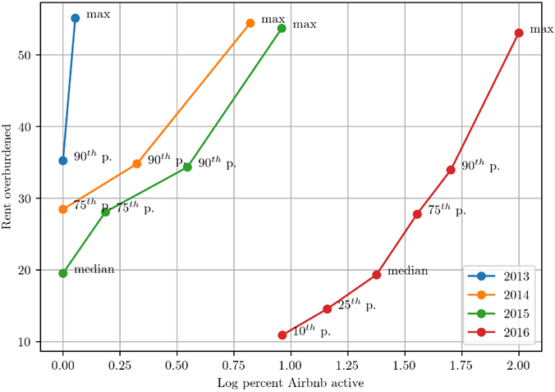

Following observations can be made from the simulation of rent overburdened households and percent Airbnb listings (as a fraction of active/occupied rental units).

* Since both the independent and dependent variables were log-transformed and fairly-low in magnitude (coefficients), we simulate the results by plotting values estimated by the model at the 10th, 25th 50th (median), 75th, 90th and 100th (max) percentile of the X variable.
* We note that for simulations for earlier years – 2013, 2014, we do not include data from percentiles below the median. The rationale behind this is that Airbnb listings proliferated in most census tracts after these years (refer to figure 7) and so the percentile values below median were clustered together and close to zero Airbnb listings.
* Each simulation shows trends for Y vs log X for years 2013 to 2016.
* Figure 9, overall trend shows that an increase in Airbnb active rentals (Airbnb listings, as a fraction of occupied/active rental housing market) corresponded to an increase in fractions of households which were rent overburdened.
* Furthermore, census tracts with a smaller presence of Airbnb listings (those below 50th percentile) were more sensitive to an increase in Airbnb listings i.e. they saw a higher increase in the rent-overburdened household category as compared to census tracts in the higher percentiles. This trend was consistent across all four years.
* A note of caution – the X axis for the simulation represents values for log of the variable and care should be taken when reading off numerical values from it.
* Another way to read the simulation graph is to look at changes in rent overburdened households for a fixed percentile mark across all four years. Doing this for all percentiles (except the maximum), we observe no significant change in the fraction of rent overburdened households over the years.
* The maximum value (100th percentile) at first glance seems to be decreasing over the years which is not the case as shown in figure 3. However, these observations can be interpreted as an indication of a trend wherein over the years, the census tracts with lower rent overburdened populations have seen a larger increase in Airbnb listings. This phenomenon results in a drop in the Y value associated with the census tracts that have maximum percentage of listings which is why the simulation for 2016 shows smaller values of Y as compared to the other years. In effect, these values should not be compared across the years without also accounting for shifting distributions of Airbnb listings.

Figure 10 Simulation of median rent vs Airbnb Listings for 2013 - 2016

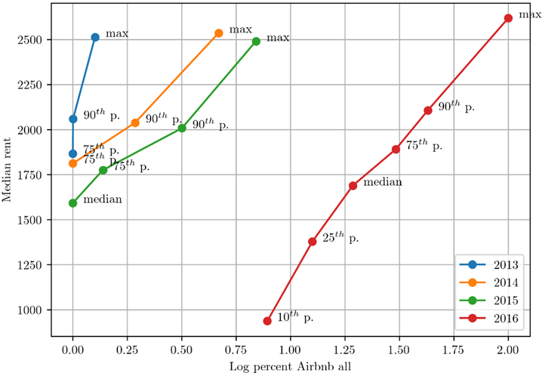

Following observations can be made from the simulation of median rents and percent Airbnb listings (as a fraction of all rental units).

* Figure 10, overall trend shows that an increase in Airbnb all rentals (Airbnb listings, as a fraction of all rental housing in the market) corresponded to an increase in the median rent per census tract.
* As before, for the early years (2013-14), we do not include data points for the lower medians in the simulation in order to avoid clustering of percentiles around zero. This is a consequence of fewer tracts having Airbnb listings during that time.
* From the graph, we observe that census tracts with a smaller presence of Airbnb listings (those below the 50th percentile) were more sensitive to an increase in Airbnb listings i.e. they saw a higher increase in the median rent per tract as compared to census tracts in the higher percentiles. This trend was consistent across all four years.
* A note of caution – the X axis for the simulation represents values for log of the variable and care should be taken when reading off numerical values from it.
* Another way to read the simulation graph is to look at changes in median rent for a fixed percentile mark across all four years. Doing this for all percentiles, we observe overall increases in the median rent over the years for each of the 50th (median), 75th, 90th and 100th (maximum) percentiles.
* Since both the y- and x- axes plot medians of the variables, one should be extra-cautious while interpreting these results as they are sensitive to the time-dependent probability distributions for these variables.

Figure 11 Simulation of median house price vs Airbnb Listings for 2013 - 2016

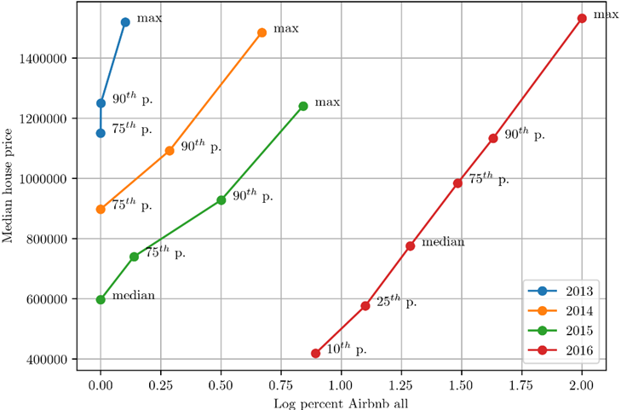

Following observations can be made from the simulation of median house prices and percent Airbnb listings (as a fraction of all rental units) –

* Figure 11, the overall trend shows that an increase in Airbnb all rentals (Airbnb listings, as a fraction of all rental housing in the market) corresponded to an increase in the median house prices in census tracts.
* As before, for the early years (2013-14), we do not include data points for the lower medians in the simulation in order to avoid clustering of percentiles around zero. This is a consequence of fewer tracts having Airbnb listings during that time.
* From the graph, we observe that census tracts with a smaller presence of Airbnb listings (those below the 50th percentile) were more sensitive to an increase in Airbnb listings i.e. they saw a higher increase in the median house price per tract as compared to census tracts in the higher percentiles. This trend was consistent across all four years.
* A note of caution – the X axis for the simulation represents values for log of the variable and care should be taken when reading off numerical values from it.
* Another way to read the simulation graph is to look at changes in median house price for a fixed percentile mark across all four years. Doing this for all percentiles, we observe a sharp and unexpected decrease in the median house price (corresponding to these percentiles) from 2013-2015. This does not mean that house prices were decreasing in any way as the real trend can be seen in the figure 3. These observations can be interpreted as an indication of a trend wherein over the years, the census tracts with lower house prices have seen a larger increase in Airbnb listings. This phenomenon results in a drop in the Y value for each of these percentiles which is why the simulation for 2013-15 shows a decreasing trend in Y. In effect, these values should not be compared across the years without also accounting for the time-dependent probability distributions for these variables since both the y- and x- axes plot percentiles of the variables.

# DISCUSSION AND CONCLUSION

Using spatial regression analyses of cross-sectional and longitudinal data specifically focusing on census tract level location, demographic, neighborhood level, job accessibility and the main – Airbnb variables across the San Francisco MSA and the SF Francisco city, we aimed to address the following: Do short-term rentals in the form of Airbnb rentals impact the rent affordability of the study area and if so then to what extent? Overall, we find a significant correlation between the indicators Airbnb’s presence (percent Airbnb listings as a fraction of total rental housing available and weighted Airbnb listings) and various rental affordability measures (rent-burdened households, rent overburdened households, median rents, and median house prices). While the correlation does not mean causation, the relative magnitudes of coefficients can be simulated for better understanding. The simulations from the spatial lag models (cross-sectional study) provide useful insights about the relationship between Airbnb and rental affordability. These also reveal that the tracts with lower percentages of Airbnb listings are more at risk of having low rental affordability as the presence of Airbnb increases.

This research also finds its motivation in connecting its findings with the regulatory debate. While a more comprehensive and deeper analysis is warranted for estimating a regulatory response (if any) to the platform, it is important to ascertain its effects both positive and negative. One critical dissection that should be acknowledged is that of the casual and commercial hosts. While the casual hosts stay true to the spirit of home-sharing i.e. utilization of underutilized/latent resources to support their incomes, the billion-dollar company seems to find its major revenue source in the commercial hosts (sometimes the super hosts) who own multiple properties and have entire house listings available throughout the year. Such hosts could have been landlords as part of the long-term rental housing stock. In a bid to investigate the revenue potential of Airbnb hosts as opposed to becoming a landlord in the same area, one can compare certain numbers available. While this analysis is not extensive, the main purpose of it is to understand how lucrative it is for the hosts to rent with Airbnb, rather than putting their property for long-term renting. The data shown is collected from AirDNA, (a paid service that provides Airbnb data analytics) mainly created to assist hosts to decide on their listing prices and better understand revenue trends. This study used the free data points that are available on the website i.e. county-wise average revenue earned by Airbnb hosts monthly (for 2017). The vacancy rates assumed for these estimates were not disclosed by the service. These revenue amounts can be compared with the gross median rent in that county to understand the difference between renting for long term vs short term. Table 6 shows the difference between renting with Airbnb (short-term) and renting lease based for long-term.

Table 7 Comparison of revenue earned as an Airbnb host to that earned as landlord.

|  |  |  |  |  |
| --- | --- | --- | --- | --- |
| **County** | **Avg. monthly revenue** | **Median gross rent** | **Ratio (revenue/rent)** | **Percent entire home listings** |
| *San Francisco* | $ 3,107 | $ 1,784 | **1.74** | 59% |
| *Alameda* | $ 2,155 | $ 1,622 | **1.33** | 59% |
| *San Mateo* | $ 2,375 | $ 2,114 | **1.12** | 42% |
| *Marin* | $ 2,298 | $ 1,921 | **1.20** | 60% |
| *Contra Costa* | $ 1,466 | $ 1,692 | **0.87** | 37% |

It can be observed that except Contra Costa County, all other counties present lucrative options for the Airbnb hosts to rent short-term instead of long-term. However, it should also be noted that the highest earning hosts are the commercial or the super hosts who host multiple entire home listings. Hence, an important consideration for regulating Airbnb and like platforms are targeted policies ensuring proliferation of casual hosts who make tourism more affordable, benefit local business and empower homeowners by providing extra income but keeping a check on the commercial hosts who can potentially skirt hotel taxes and regulations by participating in the ‘sharing’ economy model. This presents as an opportunity for planners to evaluate their policies and development controls to better respond to Airbnb and the sharing economy. These can include better zoning provisions, extensive research and analysis of neighborhoods with high Airbnb listing concentrations, keeping an eye out for gentrification indicators and affordability concerns etc. Incentives can be promoted for the casual hosts who in way stay true to the idea of sharing economy. One major challenge in this process is to establish data sharing between Airbnb and planning agencies to better gauge the impacts and extent of the model. This leaves a lot of scope for research in terms of assessing neighborhood level impacts, negative and positive externalities of increase in Airbnb listings in a certain area and the need and type of regulation needed to accommodate Airbnb and sharing economy in general.

# References

Anselin, L. (2017), *Spatial Data Science*. [Video file] Retrieved from [www.youtube.com/channel/](http://www.youtube.com/channel/)UCzvhOfSmJpRsFRF2Pgrv-Wg

Aurand, A. (2016). Out of Reach 2016: No Refuge for Low Income Renters. *National Low-*

*Income Housing Coalition.* Retrieved from: http://nlihc.org/sites/default/files/oor/OOR_2016.pdf

Barron, K., Kung, E. and Proserpio, D. (2018) *The Sharing Economy and*

*Housing Affordability: Evidence from Airbnb.* Retrieved from SSRN: https://ssrn.com/abstract=3006832

Budget and legislative analyst (2016) Policy Analysis Report, Board of Supervisors, *City*

*and County of San Francisco.* Retrieved from: https://sfbos.org/sites/default/files/FileCenter/Documents/55575-BLA.ShortTermRentals%20040716.pdf

Bensinger, G. (2017) Airbnb Valued at $31 Billion After New Funding Round; Home-sharing

site adds $1 billion cash cushion to stave off IPO, *Wall Street Journal* (Online); New York, N.Y. Retrieved from: <https://www.wsj.com/articles/airbnb-valued-at-31-billion-after-new-funding-round-1489086240>

Codagnone, C. and Martens, B. (2016). Scoping the Sharing Economy: Origins,

Definitions, Impact and Regulatory Issues. *Institute for Prospective Technological Studies Digital Economy Working Paper 2016/01*. DOI: JRC100369

Codagnone, C., Biagi, F., and Abadie, F. : The Passions and the Interests:

Unpacking the 'Sharing Economy'. *Institute for Prospective Technological Studies, JRC Science for Policy Report EUR 27914 EN,* DOI:10.2791/474555

Gutierrez, J., Garcia, J., Romanillos, G. and Olmedo. M. (2016). The eruption of airbnb in tourist cities: comparing spatial patterns of hotels and peer-to-peer accommodation. *Tourirm Management, Elsevier Ltd*. Retrieved from: http://isiarticles.com/bundles/Article/pre/pdf/148944.pdf

Guttentag, D. (2015). Airbnb: disruptive innovation and the rise of an informal tourism

accommodation sector. *Current Issues in Tourism*, 10(12), 1192-1217.

Hooijer, P. (2016). The Relationship between Airbnb and the Hotel Revenue: Evidence

from The Netherlands. *University of Amsterdam.* Retrieved from: http://www.scriptiesonline.uba.uva.nl/608470

Kaplan, R. A. (2015). Airbnb: A Case Study in Occupancy Regulation and Taxation.

*The University of Chicago Law Review Dialogue*, p103-115.

Lee, D. (2015). How Airbnb Short-Term Rentals Exacerbate Los Angeles’s Affordable Housing

Crisis: Analysis and Policy Recommendations. 10, 229-253.

Malhotra, A., and Van Alstyne, M. (2014). The dark side of the sharing economy and how to

lighten it. *Communications of the ACM*, 57, 24-27.

Meni, D. (2017, March 21). Are Airbnbs driving up your rent? Retrieved from:

https://ggwash.org/view/62774/are-airbnbs-driving-up-your-rent

Gurran, N. and Phibbs, P. (2017) When Tourists Move In: How Should Urban Planners

Respond to Airbnb?, *Journal of the American Planning Association,* 83:1, 80-92, DOI:

10.1080/01944363.2016.1249011

O’Sullivan, F. (2015, December 23). Tourist-Heavy Barcelona Is Cracking Down on Airbnb. Retrieved from: https://www.citylab.com/equity/2015/12/barcelona-airbnb-tourism/421788/

PricewaterhouseCoopers (PwC) report. (2014). The sharing economy: How will it disrupt your

business? Retrieved from – [www.pwc.co.uk/economic-policy/index.jhtml](http://www.pwc.co.uk/economic-policy/index.jhtml)

Quattrone, G., Proserpio, D., Quercia, D., Capra, L., and Musolesi, M. (2016). Who Beneﬁts

from the “Sharing” Economy of Airbnb? *Cornel University Library* Retrieved from: https://arxiv.org/pdf/1602.02238

Shaheen, S., Sperling, D., and Wagner, C. (1999). A Short History of Carsharing in the 90's.

*Journal of World Transport Policy and Practice*, 5(3), 18-40.

Shephard, S. and Udell, A. (2016). Do Airbnb properties affect house prices?

*New York State Office of the Attorney General,* supra note 42 at 2, 10-11. Retrieved from: https://ag.ny.gov/pdfs/AIRBNB%20REPORT.pdf

Streitfeld, D. (2014, October 15). Airbnb Listings Mostly Illegal*,* New York State Contends. *New York Times.* Retrieved from: https://www.nytimes.com/2014/10/16/business/airbnb-listings-mostly-illegal-state-contends.html

Stulberg, A. (2016). Airbnb Probably Isn’t Driving Rents Up Much, At Least Not Yet. Retrieved from: https://fivethirtyeight.com/features/airbnb-probably-isnt-driving-rents-up-much-at-least-not-yet/

Zervas, G., Byers, J. and Proserpio, D. (2016). The Rise of the Sharing Economy: Estimating the Impact of Airbnb on the Hotel Industry. Retrieved from: http://people.bu.edu/zg/publications/airbnb.pdf

# Appendix A – ArcGIS map outputs

Location variables generated through ArcGIS analysis -

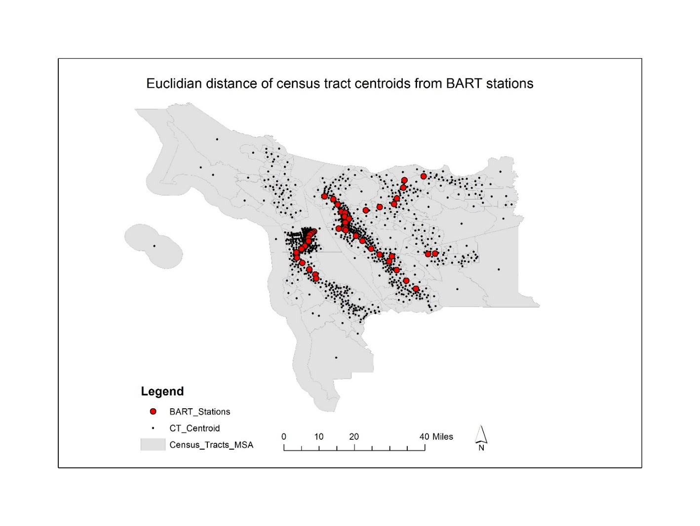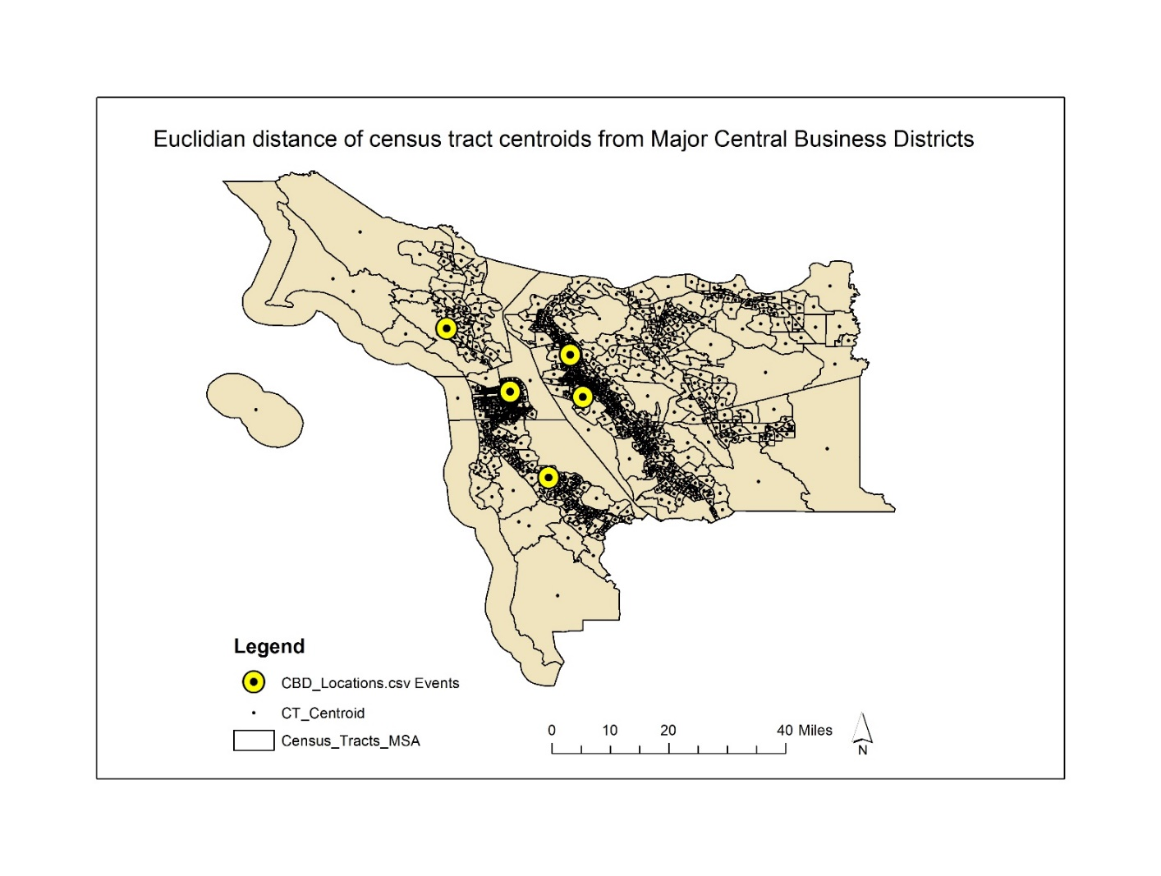

# Appendix B - Graphs depicting distribution of Airbnb listings and data repository

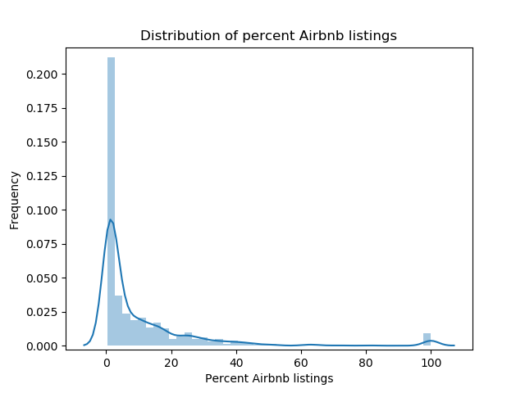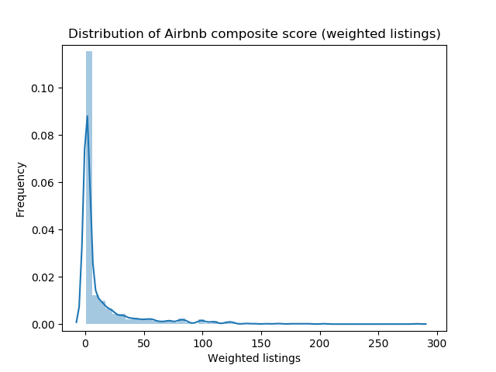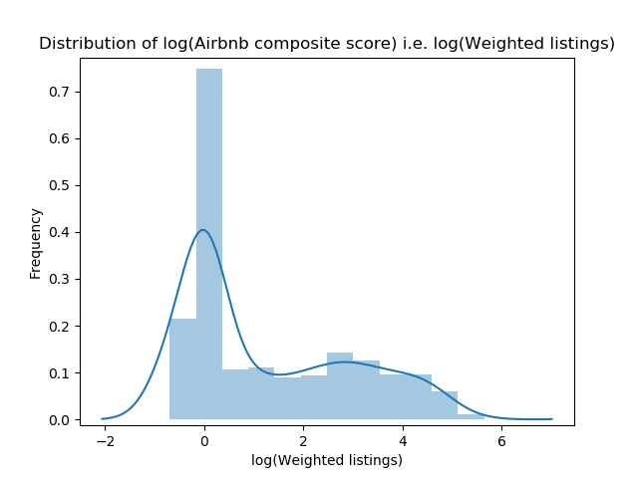

Data repository and version-controlled code

Available at - [git@gitlab.engr.illinois.edu:sukanya3/Airbnb_Spatial_Econometrics.git](mailto:git@gitlab.engr.illinois.edu:sukanya3/Airbnb_Spatial_Econometrics.git)

Appendix C – Simulation outputs of all the cross-sectional model variables

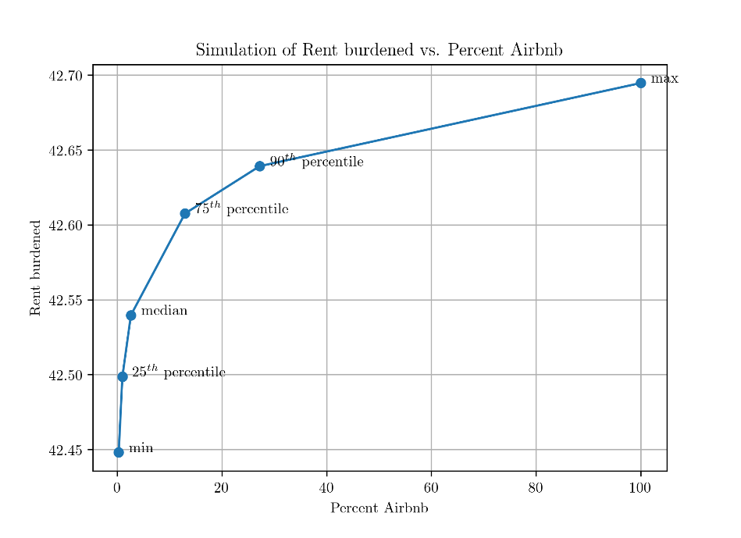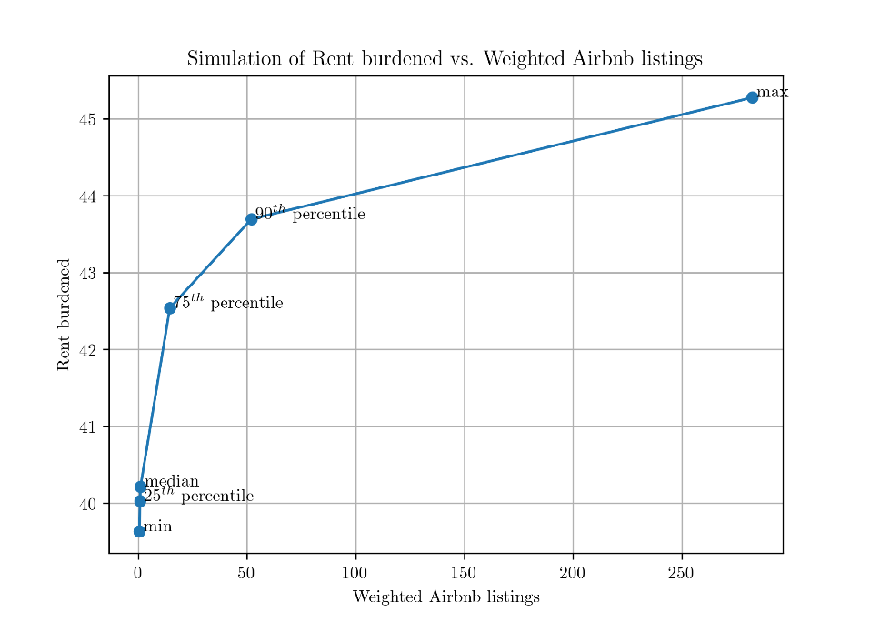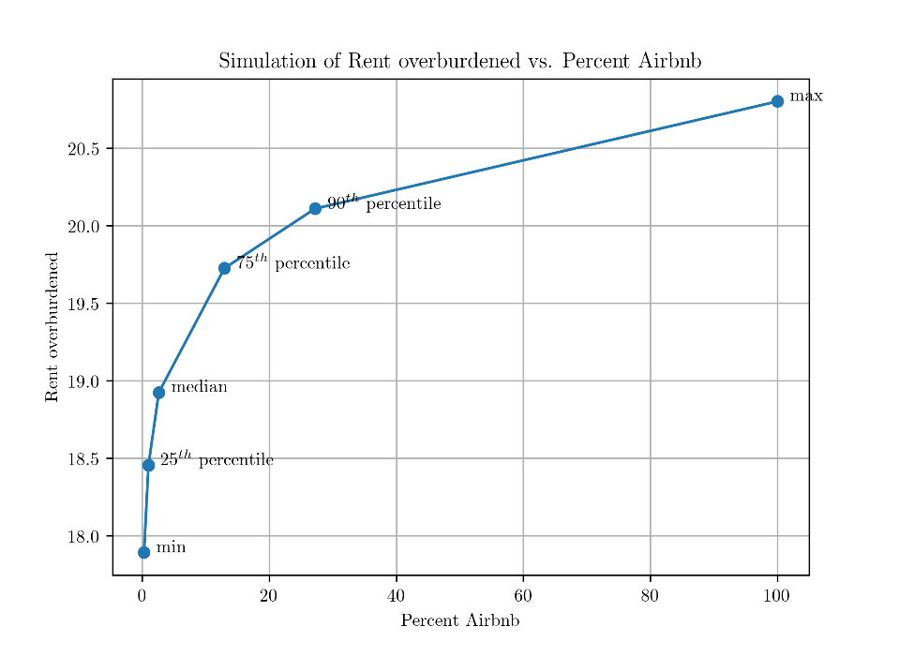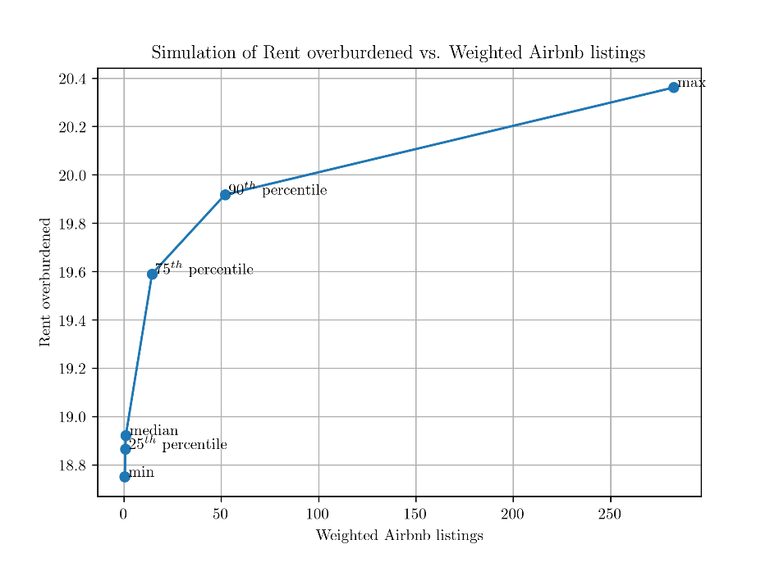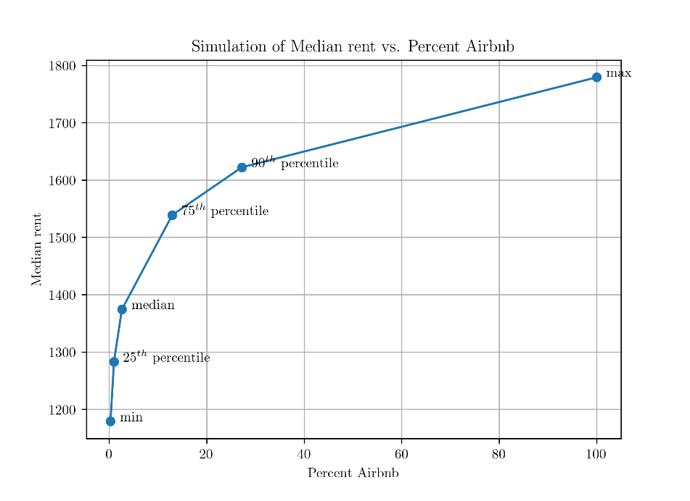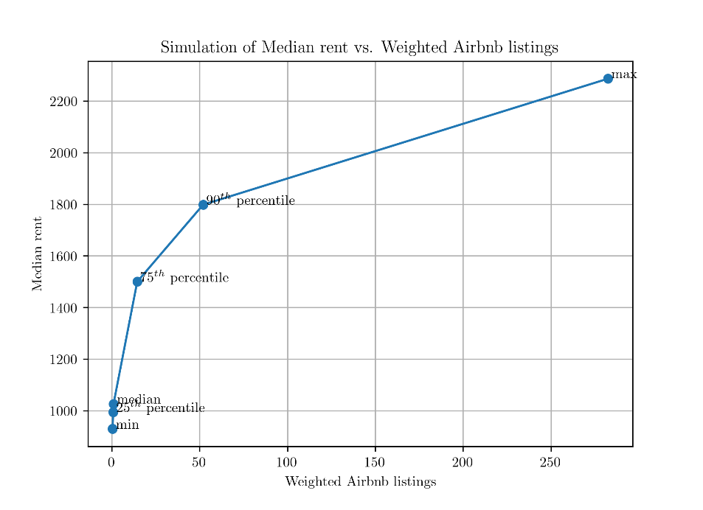

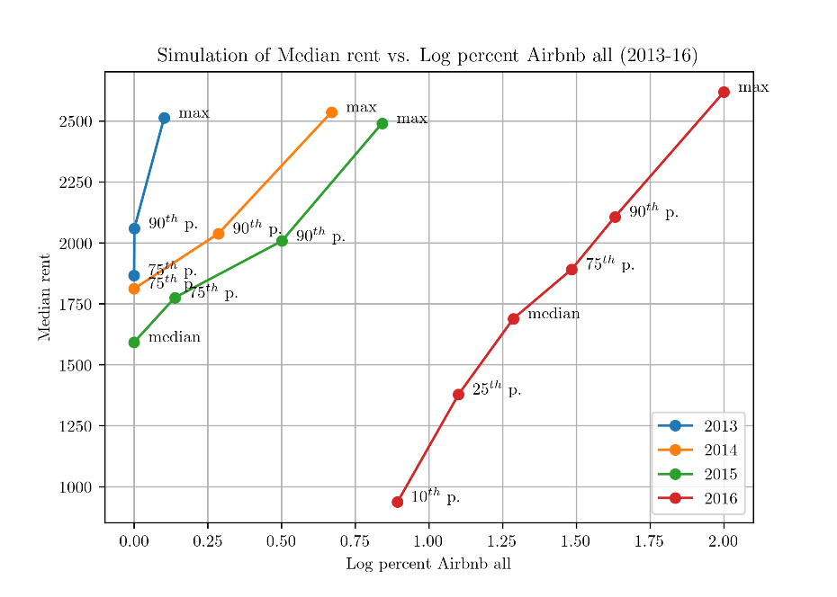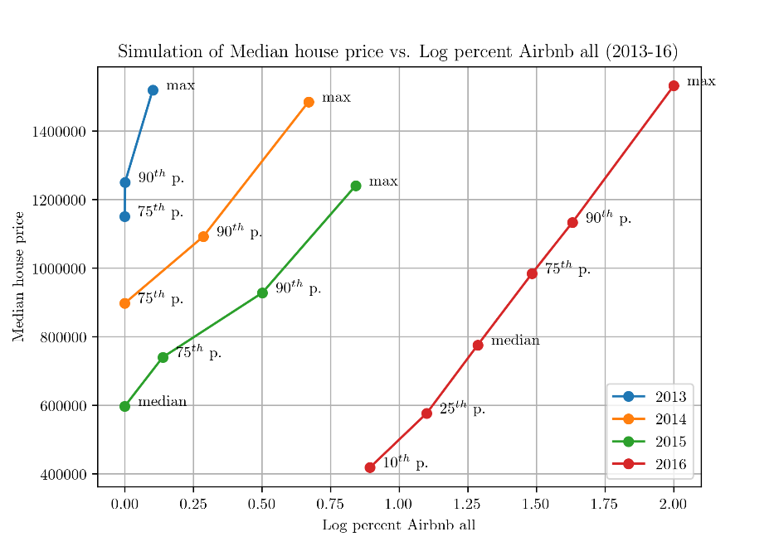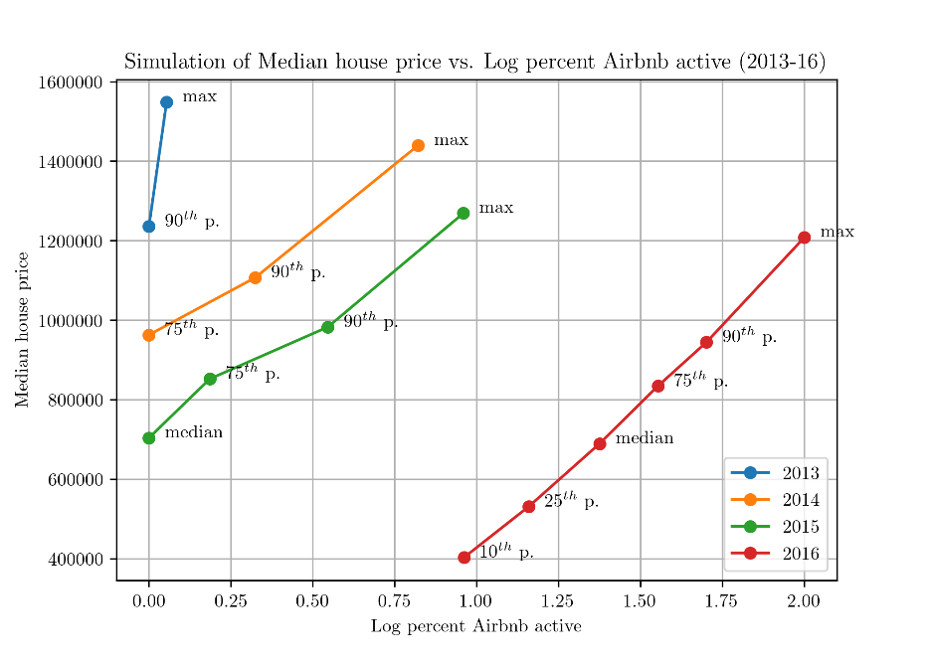Figures below show the simulations run with all the longitudinal model variables -

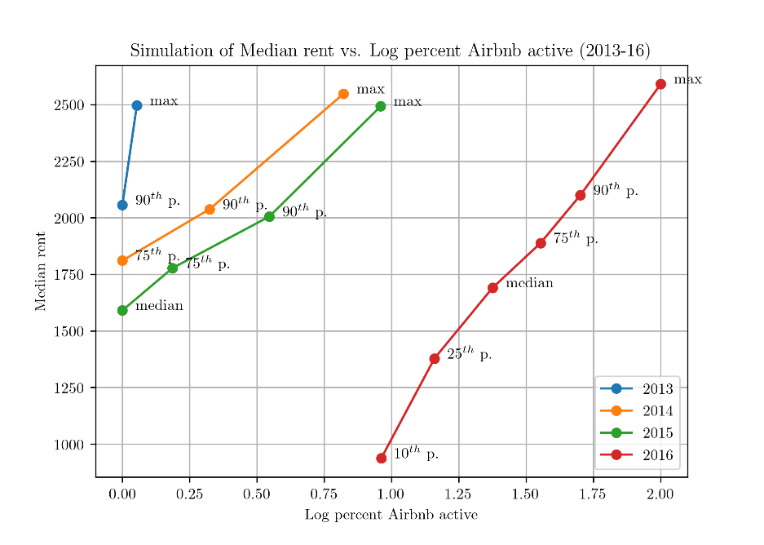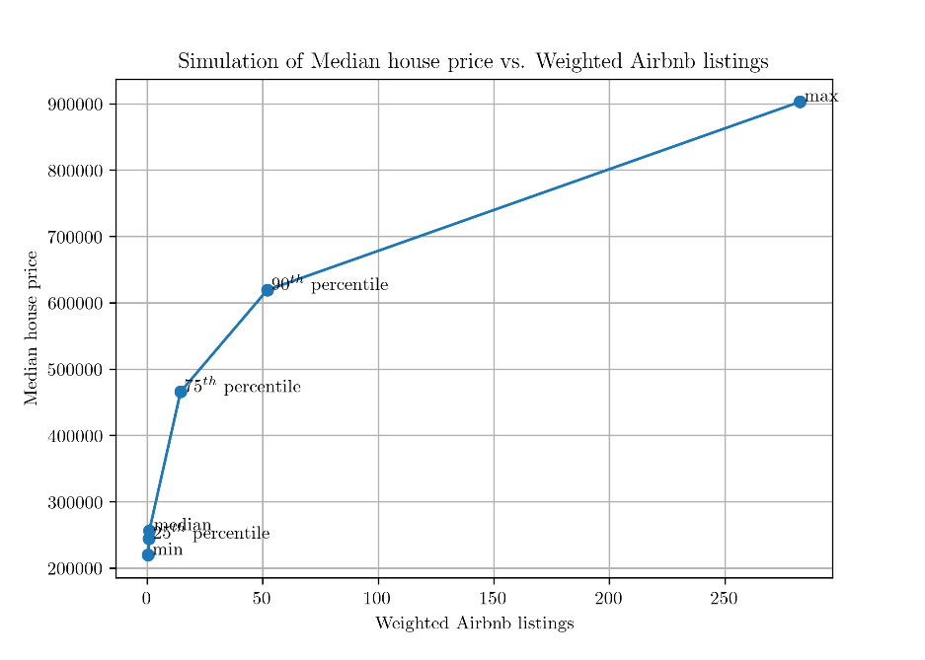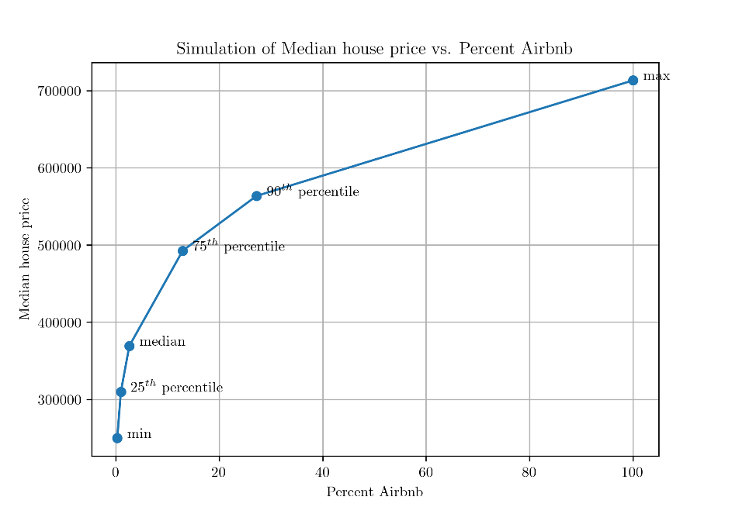

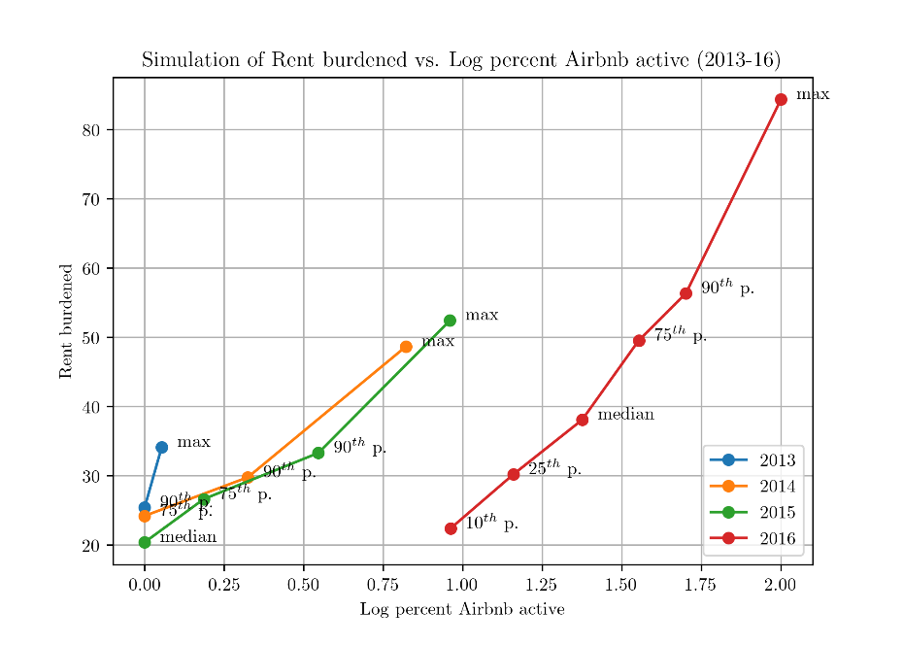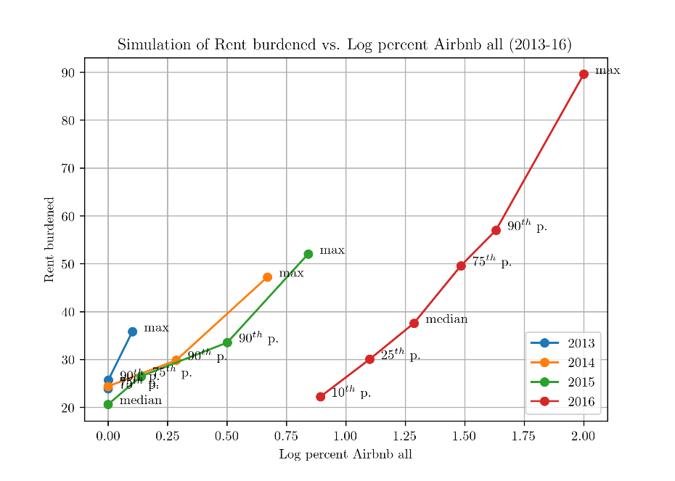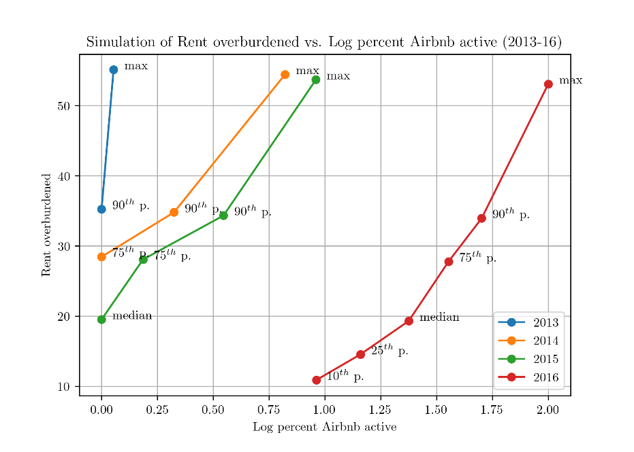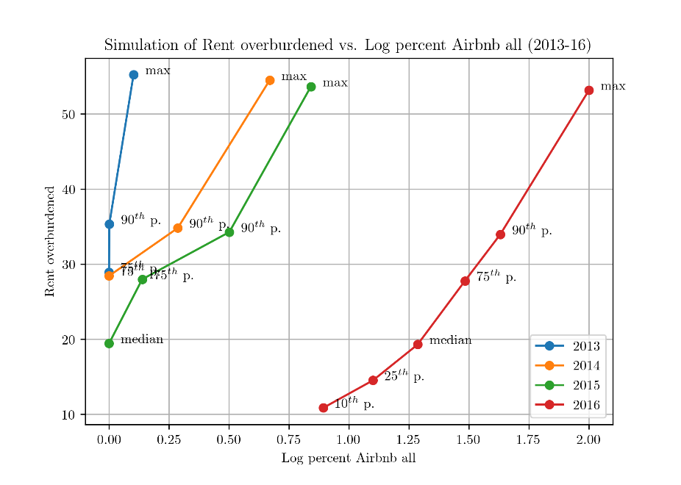

Figures below show affordability trends for each county of the San Francisco MSA –

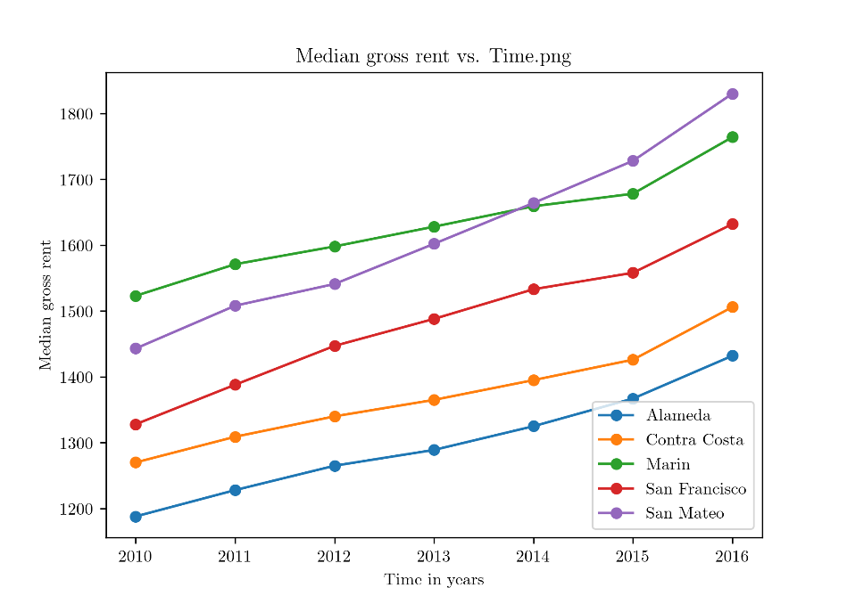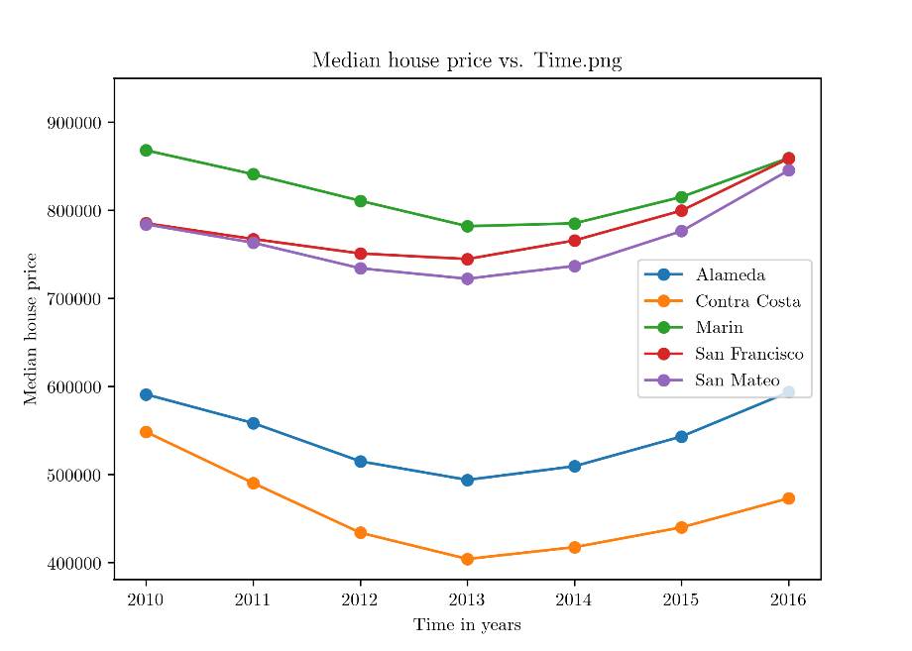

1. percentage households spending 30% or more of gross monthly income towards total housing costs
2. percentage households spending 50% or more of gross monthly income towards total housing costs
3. Bensinger, Greg. Airbnb Valued at $31 Billion After New Funding Round; Home-sharing site adds $1 billion cash cushion to stave off IPO, Wall Street Journal (Online); New York, N.Y. 09 Mar 2017. Retrieved from: <https://www.wsj.com/articles/airbnb-valued-at-31-billion-after-new-funding-round-1489086240>
4. New York State Office of the Attorney General, supra note 42 at 2, 10-11.
5. Anselin Luc (2017), Spatial Data Science. Videos available at https://www.youtube.com/channel/UCzvhOfSmJpRsFRF2Pgrv-Wg
6. Available at GitLab (<https://gitlab-beta.engr.illinois.edu/sukanya3/Airbnb_Spatial_Econometrics>) under open license
7. Rental housing data obtained from 2016 ACS estimates
8. Methodology used by Great Schools non-profit. Retrieved from <https://www.greatschools.org/gk/ratings-methodology/>
9. Inspired by the script developed and shared by Yongsung Lee, a Ph.D. candidate at School of City and Regional Planning, Georgia Institute of Technology